**HUMAN ANATOMY & PHYSIOLOGY**

**1.0. Homeostasis**

**Homeostasis**, any self-regulating process by which biological systems tend to maintain stability while adjusting to conditions that are optimal for survival. If [homeostasis](https://www.merriam-webster.com/dictionary/homeostasis) is successful, [life](https://www.britannica.com/science/life) continues; if unsuccessful, disaster or [death](https://www.britannica.com/science/death) ensues. The stability attained is actually a [dynamic equilibrium](https://www.britannica.com/science/equilibrium-physics), in which continuous change occurs yet relatively uniform conditions prevail.

Any system in [dynamic](https://www.merriam-webster.com/dictionary/dynamic) [equilibrium](https://www.merriam-webster.com/dictionary/equilibrium) tends to reach a steady state, a balance that resists outside forces of change. When such a system is disturbed, built-in regulatory devices respond to the departures to establish a new balance; such a process is one of [feedback](https://www.britannica.com/science/feedback-biology) [control](https://www.britannica.com/technology/control-system). All processes of [integration](https://www.merriam-webster.com/dictionary/integration) and coordination of function, whether mediated by [electrical circuits](https://www.britannica.com/technology/electric-circuit) or by [nervous](https://www.britannica.com/science/nervous-system) and [hormonal](https://www.britannica.com/science/hormone) systems, are examples of homeostatic regulation.

**bioelectricity**, electric potentials and currents produced by or occurring within living organisms. [Bioelectric potentials](https://www.britannica.com/science/bioelectric-potential) are generated by a variety of biological processes and generally range in strength from one to a few hundred millivolts.

**fluid compartment:**fluid inside all cells of the body constitutes a compartment system that is largely segregated from other systems

**hydrostatic pressure:**pressure exerted by a fluid against a wall, caused by its own weight or pumping force

**interstitial fluid (IF):**fluid in the small spaces between cells not contained within blood vessels

**intracellular fluid (ICF):**fluid in the cytosol of cells

**2.1. Fluid Compartments**

Body fluids can be discussed in terms of their specific **fluid compartment**, a location that is largely separate from another compartment by some form of a physical barrier. The **intracellular fluid (ICF)** compartment is the system that includes all fluid enclosed in cells by their plasma membranes. **Extracellular fluid (ECF)** surrounds all cells in the body. Extracellular fluid has two primary constituents: the fluid component of the blood (called plasma) and the **interstitial fluid (IF)** that surrounds all cells not in the blood.

1. **Intracellular Fluid**

The ICF lies within cells and is the principal component of the cytosol/cytoplasm. The ICF makes up about 60 percent of the total water in the human body, and in an average-size adult male, the ICF accounts for about 25 liters (seven gallons) of fluid. This fluid volume tends to be very stable, because the amount of water in living cells is closely regulated. If the amount of water inside a cell falls to a value that is too low, the cytosol becomes too concentrated with solutes to carry on normal cellular activities; if too much water enters a cell, the cell may burst and be destroyed.

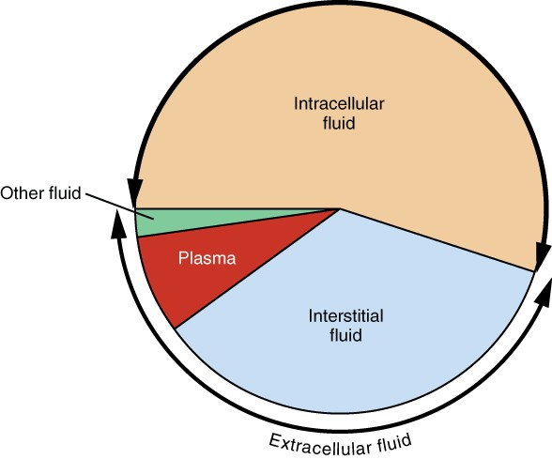

Figure 3. Most of the water in the body is intracellular fluid. The second largest volume is the interstitial fluid, which surrounds cells that are not blood cells.

1. **Extracellular Fluid**

The ECF accounts for the other one-third of the body’s water content. Approximately 20 percent of the ECF is found in plasma. Plasma travels through the body in blood vessels and transports a range of materials, including blood cells, proteins (including clotting factors and antibodies), electrolytes, nutrients, gases, and wastes. Gases, nutrients, and waste materials travel between capillaries and cells through the IF. Cells are separated from the IF by a selectively permeable cell membrane that helps regulate the passage of materials between the IF and the interior of the cell.

The body has other water-based ECF. These include the cerebrospinal fluid that bathes the brain and spinal cord, lymph, the synovial fluid in joints, the pleural fluid in the pleural cavities, the pericardial fluid in the cardiac sac, the peritoneal fluid in the peritoneal cavity, and the aqueous humor of the eye. Because these fluids are outside of cells, these fluids are also considered components of the ECF compartment.

**2.2.2. Composition of Body Fluids**

The compositions of the two components of the ECF—plasma and IF—are more similar to each other than either is to the ICF. Blood plasma has high concentrations of sodium, chloride, bicarbonate, and protein. The IF has high concentrations of sodium, chloride, and bicarbonate, but a relatively lower concentration of protein. In contrast, the ICF has elevated amounts of potassium, phosphate, magnesium, and protein. Overall, the ICF contains high concentrations of potassium and phosphate, whereas both plasma and the ECF contain high concentrations of sodium and chloride.

**2.3. Sources of body fluids**

Body fluids are considered to be the **interstitial fluids, saliva, tears, and gastric juices**. They moisten the tissues, muscles, body organs and skin

Body fluids are liquids originating from **inside the bodies of living humans** and play a vital role within our bodies. They are made up of proteins and are excreted or secreted from the body.

1. **Sources of Electrolytes**

The best way to reach and maintain electrolyte balance is through a healthy diet.

The main food sources of electrolytes are fruits and vegetables. However, in the Western diet, a common source of sodium and chloride is table salt.

Below are some foods that provide electrolytes ([28](http://nutritiondata.self.com/foods-000123000000000000000-w.html), [29](http://nutritiondata.self.com/foods-011122000000000000000-1w.html), [30](http://nutritiondata.self.com/foods-000118000000000000000-w.html)):

* **Sodium:**Pickled foods, cheese and table salt.
* **Chloride:**Table salt.
* **Potassium:**Fruits and vegetables like bananas, [avocado](https://www.healthline.com/nutrition/12-proven-benefits-of-avocado) and sweet potato.
* **Magnesium:**Seeds and nuts.
* **Calcium:**Dairy products, fortified dairy alternatives and [green leafy vegetables](https://www.healthline.com/nutrition/leafy-green-vegetables).

**i. Functions of electrolytes**

1. **Nervous System Function**

Your brain sends electrical signals through your nerve cells to communicate with the cells throughout your body.

1. **Function**

The electrolyte [calcium](https://www.healthline.com/nutrition/calcium-supplements) is needed for muscle contraction

1. **Proper Hydration**

Water must be kept in the right amounts both inside and outside each cell in your body

1. **Internal pH Levels**

To stay healthy, your body needs to regulate its internal pH

* + 1. **Sources of water in the body**

You get some of the water in your body through the foods you eat. Some of the water is made during the process of metabolism. You also get water through liquid foods and beverages, such as **soup, milk, tea, coffee, soda, drinking water, and juices**. Alcohol is not a source of water because it is a diuretic.

**i. Functions of water in the body**

* Regulates body temperature.
* Moistens tissues in the eyes, nose and mouth.
* Protects body organs and tissues.
* Carries nutrients and oxygen to cells.
* Lubricates joints.
* Lessens burden the on kidneys and liver by flushing out waste products.
  1. **Fluid and electrolyte homeostasis is maintained in the body**

Fluid and electrolyte homeostasis is maintained by feedback mechanisms, hormones, and many organ systems, and is necessary for the body's normal physiologic functions. Disorders of sodium and water, calcium, phosphorus, potassium, and magnesium

**2.0. The Human Digestive System**

The digestive system of the human body comprises a group of organs working together to convert food into energy for the body. Anatomically, the digestive system is made up of the gastrointestinal tract, along with accessory organs such as the liver, pancreas and gallbladder. The hollow organs that make up the gastrointestinal tract (GI tract) include the mouth, stomach, oesophagus, small intestine and large intestine that contains the rectum and anus.

Human Digestive System and Nutrition involve the intake of food by an organism and its utilization for energy. This is a vital process which helps living beings to obtain their energy from various sources. The food which we eat undergoes much processing before the nutrients present in them are utilized to generate energy. This processing is known as digestion. Humans and other animals have specialized organs and systems for this process.

The digestion process involves the alimentary canal along with various accessory organs and organ systems. In humans, the process is quite simple due to our monogastric nature. This means that we have a one-chambered stomach, unlike other animals such as cows, which have four chambers.

Some parts of nervous and circulatory systems also play a significant role in the digestion process. A combination of nerves, bacteria, hormones, blood and other organs of the digestive system completes the task of digestion.

Let us have a detailed look at the human digestive system, its parts and functions. Also provided at the end of the chapter are digestive system notes.

Diagram Of The Human Digestive System

The diagram given below represents different parts of the human digestive system that convert food into essential nutrients absorbed by the body.

Parts of the Human Digestive System

The digestive system of the human body comprises a group of organs that work together in converting food into energy and other basic nutrients to power the body. The food we take in is digested and utilized by our body, and the unused parts of the food are defecated.

The digestive system of the human body is the sum of the gastrointestinal tract (GIT; also called alimentary canal) and accessory organs (tongue, liver, pancreas, etc.). These two parts together help in the digestion process.

The alimentary canal is the long tube through which the food that we eat is passed. It begins at the mouth (buccal or oral cavity), passes through the pharynx, oesophagus or food pipe, stomach, small intestines, large intestines, rectum and finally ends at the anus. The food particles gradually get digested as they travel through various compartments of the alimentary canal.

**Accessory organs** are organs which participate in the digestion process but are not actually a part of GIT. They stimulate the digestion by releasing certain enzymes that help in breaking down the food.

Let us have a detailed look at the digestive system of the human body, along with its parts and functions:

Mouth

Food starts its journey from the mouth or the oral cavity. There are many other organs that contribute to the digestion process, including teeth, salivary glands, and tongue. Teeth are designed for grinding food particles into small pieces and are moistened with saliva before the tongue pushes the food into the pharynx.

Pharynx

A fibromuscular y-shaped tube attached to the terminal end of the mouth. It is mainly involved in the passage of chewed/crushed food from the mouth through the oesophagus. It also has a major part in the respiratory system, as air travels through the pharynx from the nasal cavity on its way to the lungs.

Oesophagus

This is a muscular tube that connects the pharynx, which is a part of an upper section of the gastrointestinal tract. It supplies swallowed food along with its length.

Stomach

It serves as a muscular bag which is situated towards the left side of the abdominal cavity, beneath the diaphragm. This vital organ acts as a storage for the food and provides enough time to digest meals. The stomach also produces digestive enzymes and hydrochloric acid that maintains the process of digestion.

* **Mucous**: It is an aqueous secretion produced by the mucous membranes. It functions by protecting the stomach lining and gastric pits from the acid, which is produced by the glands to destroy the bacteria that entered along with the food particles.
* **Digestive enzymes**: They are the group of enzymes which functions by breaking down polymeric macromolecules like biopolymers into their smaller and simpler substances.
* **Hydrochloric acid**: It is the digestive fluid formed by the stomach during the process of digestion. It functions by destroying harmful microorganisms present in the food particles.

Small Intestine

The [small intestine](https://byjus.com/biology/the-small-intestine/) is a thin, long tube of about 10 feet long and a part of the lower gastrointestinal tract. It is present just behind the stomach and acquires a maximum area of the abdominal cavity. The complete small intestine is coiled and the inner surface consists of folds and ridges.

Large Intestine

This is a thick, long tube measuring around 5 feet in length. It is present just beneath the stomach and wraps over the superior and lateral edges of the small intestine. It absorbs water and consists of bacteria (symbiotic) that support the breakdown of wastes to fetch small nutrients.

Rectum

Waste products are passed into the end of the large intestine called the rectum and eliminated out of the body as a solid matter called stool. It is stored in the rectum as semi-solid faeces which later exits from the body through the anal canal through the process of defecation.

Accessory Organs

Pancreas

It is a large gland present just behind the stomach. It is short with its anterior connected to the duodenum and posterior pointing towards the left part of the abdominal cavity. The pancreas releases digestive enzymes to complete the process of chemical digestion.

Liver

The liver is a roughly triangular, reddish-brown accessory organ of the digestive system located to the right of the stomach. It produces [bile](https://byjus.com/biology/composition-of-bile-juice/), which helps in the digestion of fat in the small intestine. The bile is stored and recycled in the gallbladder. It is a small, pear-shaped organ which is located just next to the liver.

Digestion Process

The process of digestion begins from the mouth and ends in the small intestine – the large intestines’ main function is to absorb the remaining water from the undigested food and enable bacterial fermentation of materials that can no longer be digested.

The alimentary canal or the gastrointestinal tract is a series of hollow organs and tubes that begins from the mouth cavity and continues into the pharynx, through the stomach, small intestines, large intestines, and finally ending at the anus. Food particles gradually get digested as they travel through various compartments of the gastrointestinal tract.

The digestion process takes place in the following steps.

Ingestion

The very first step involves mastication (chewing). The salivary glands, along with the tongue, helps to moisten and lubricate food, before being pushed down into the food pipe.

Mixing and Movement

It involves the process of lubricating and manipulating food and pushing it down the food through the food pipe (using [peristalsis](https://byjus.com/biology/peristalsis/)), and into the stomach.

Secretion

The stomach, small intestine, liver, and pancreas secrete enzymes and acids to aid the process of digestion. It functions by breaking down food particles into simple components and easily absorbable components.

Digestion

The process of converting complex food particles into simpler substances in the presence of enzymes and acids secreted by different digestive organs.

Absorption

This process begins in the small intestine where most of the nutrients and minerals are absorbed. The excess water in the indigestible matter is absorbed by the large intestines.

Excretion

The process of removing indigestible substances and waste by-products from the body through the process of defecation.

In a nutshell, the digestion process consists of the six following steps:

**Ingestion**⇒**Mixing and Movement** ⇒ **Secretion**⇒ **Digestion**⇒**Absorption**⇒**Excretion**

Disorders of the Human Digestive System

**Vomiting**: It is the ejection of stomach contents through the mouth.

**Diarrhoea**: It is the abnormal watery bowel movement. Prolonged diarrhoea eventually leads to dehydration.

**Constipation**: A condition in which the faeces are clutched within the rectum due to an irregular bowel movement.

**Indigestion**: A pain or discomfort in the stomach which is caused when food is not digested properly, resulting in the feeling of fullness.  Indigestion is mainly caused due to inadequate enzyme secretion, food poisoning, anxiety, overeating and eating spicy foods.

Functions of the Human Digestive System

Digestion and absorption are the two main functions of the digestive system.

Digestion is necessary for breaking down food particles into nutrients that are used by the body as an energy source, cell repair and growth.

Food and drink need to be converted into smaller molecules of [nutrients](https://byjus.com/biology/nutrients/) before it is absorbed by the blood and carried to the cells throughout the body. The body breaks the nutrients present in the drinks and food into carbohydrates, vitamins, fats and protein

**3.0. Human Respiratory System**

To gain a clearer understanding, we have illustrated the human respiratory system and its different parts involved in the process.

Human Respiratory System Diagram showing different parts of the Respiratory Tract

Features of the Human Respiratory System

The respiratory system in humans has the following important features:

* The energy is generated by the breakdown of glucose molecules in all living cells of the human body.
* Oxygen is inhaled and is transported to various parts and are used in the process of burning food particles (breaking down glucose molecules) at the cellular level in a series of chemical reactions.
* The obtained glucose molecules are used for discharging energy in the form of ATP- (adenosine triphosphate)

Respiratory System Parts and Functions

Let us have a detailed look at the different parts of the respiratory system and their functions.

Nose

Humans have exterior nostrils, which are divided by a framework of cartilaginous structure called the septum. This is the structure that separates the right nostril from the left nostril. Tiny hair follicles that cover the interior lining of nostrils act as the body’s first line of defence against foreign [pathogens](https://byjus.com/biology/pathogen/). Furthermore, they provide additional humidity for inhaled air.

Larynx

Two cartilaginous chords lay the framework for the larynx. It is found in front of the neck and is responsible for vocals as well as aiding respiration. Hence, it is also informally called the voice box. When food is swallowed, a flap called the epiglottis folds over the top of the windpipe and prevents food from entering into the larynx.

Pharynx

The nasal chambers open up into a wide hollow space called the pharynx. It is a common passage for air as well as food. It functions by preventing the entry of food particles into the windpipe. The epiglottis is an elastic cartilage, which serves as a switch between the larynx and the oesophagus by allowing the passage of air into the lungs, and food in the [gastrointestinal tract](https://byjus.com/biology/gastrointestinal-tract/).

Have you ever wondered why we cough when we eat or swallow?

Talking while we eat or swallow may sometimes result in incessant coughing. The reason behind this reaction is the epiglottis. It is forced to open for the air to exit outwards and the food to enter into the windpipe, triggering a cough.

Trachea

The trachea or the windpipe rises below the larynx and moves down to the neck. The walls of the trachea comprise C-shaped cartilaginous rings which give hardness to the trachea and maintain it by completely expanding. The trachea extends further down into the breastbone and splits into two bronchi, one for each lung.

Bronchi

The trachea splits into two tubes called the bronchi, which enter each lung individually. The bronchi divide into secondary and tertiary bronchioles, and it further branches out into small air-sacs called the alveoli. The alveoli are single-celled sacs of air with thin walls. It facilitates the exchange of oxygen and carbon dioxide molecules into or away from the bloodstream.

Lungs

Lungs are the primary organs of respiration in humans and other vertebrates. They are located on either side of the heart, in the thoracic cavity of the chest. Anatomically, the lungs are spongy organs with an estimates total surface area between 50 to 75 sq meters. The primary function of the lungs is to facilitate the exchange of gases between the blood and the air. Interestingly, the right lung is quite bigger and heavier than the left lung.

Respiratory Tract

The respiratory tract in humans is made up of the following parts:

* **External nostrils** – For the intake of air.
* **Nasal chamber** – which is lined with hair and mucus to filter the air from dust and dirt.
* **Pharynx** – It is a passage behind the nasal chamber and serves as the common passageway for both air and food.
* **Larynx** – Known as the soundbox as it houses the vocal chords, which are paramount in the generation of sound.
* **Epiglottis** – It is a flap-like structure that covers the glottis and prevents the entry of food into the windpipe.
* **Trachea** – It is a long tube passing through the mid-thoracic cavity.
* **Bronchi** – The trachea divides into left and right bronchi.
* **Bronchioles** – Each bronchus is further divided into finer channels known as bronchioles.
* **Alveoli** – The bronchioles terminate in balloon-like structures known as the alveoli.
* **Lungs** – Humans have a pair of lungs, which are sac-like structures and covered by a double-layered membrane known as pleura.

Air is inhaled with the help of nostrils, and in the nasal cavity, the air is cleansed by the fine hair follicles present within them. The cavity also has a group of blood vessels that warm the air. This air then passes to the pharynx, then to the larynx and into the trachea.

The trachea and the bronchi are coated with ciliated epithelial cells and goblet cells (secretory cells) which discharge mucus to moisten the air as it passes through the respiratory tract. It also traps the fine bits of dust or pathogen that escaped the hair in the nasal openings. The motile cilia beat in an ascending motion, such that the mucus and other foreign particles are carried back to the buccal cavity where it may either be coughed out (or swallowed.)

Once the air reaches the bronchus, it moves into the bronchioles, and then into the alveoli.

Respiratory System Functions

The functions of the human respiratory system are as follows:

Inhalation and Exhalation

The respiratory system helps in breathing (also known as pulmonary ventilation.) The air inhaled through the nose moves through the pharynx, larynx, trachea and into the lungs. The air is exhaled back through the same pathway. Changes in the volume and pressure in the lungs aid in pulmonary ventilation.

Exchange of Gases between Lungs and Bloodstream

Inside the lungs, the oxygen and carbon dioxide enter and exit respectively through millions of microscopic sacs called alveoli. The inhaled oxygen diffuses into the pulmonary capillaries, binds to haemoglobin and is pumped through the bloodstream. The carbon dioxide from the blood diffuses into the alveoli and is expelled through exhalation.

Also read: [Exchange Of Gases in Plants](https://byjus.com/biology/exchange-of-gases/)

Exchange of Gases between Bloodstream and Body Tissues

The blood carries the oxygen from the lungs around the body and releases the oxygen when it reaches the capillaries. The oxygen is diffused through the capillary walls into the body tissues. The carbon dioxide also diffuses into the blood and is carried back to the lungs for release.

The Vibration of the Vocal Cords

While speaking, the muscles in the larynx move the arytenoid cartilage. These cartilages push the vocal cords together. During exhalation, when the air passes through the vocal cords, it makes them vibrate and creates sound.

Olfaction or Smelling

During inhalation, when the air enters the nasal cavities, some chemicals present in the air bind to it and activate the receptors of the [**nervous system**](https://byjus.com/biology/nervous-system/) on the cilia. The signals are sent to the olfactory bulbs via the brain.

4.0. HUMAN NERVIOUS SYSTEM

Living organisms adapt to their moves and positions in response to the environmental changes for their protection or to their advantage. When an entity reacts to the changes in its surroundings, it is referred to as stimulus while the reaction to the stimulus is referred to as a response. Common stimuli are sound, light, air, heat, smell, taste, water and gravity.

Think of burning your finger of fracturing your bone without any pain sensation. It may certainly sound like a superpower or an ideal situation, however, when it comes to the standpoint of survival, it can be disastrous.

The characteristic behaviour of living entities is to respond to stimuli with the intervention of the nervous system. It is an organ system ascribed to send signals from the spinal cord and the brain throughout the body and then back from all the body parts to the brain. The neuron acts as the mediator and is the basic signalling unit of the nervous system.

Pain is the body’s way of letting us know that something is not right. It can prevent further injuries or push us to seek medical attention. Moreover, all of this is possible because humans can respond and react to stimuli due to control and coordination among the various organs and organ systems.

Control and Coordination in simple multicellular organisms take place through only the Nervous system which coordinates activities of our body. It is the control system for all our actions, thinking, and behaviour.

What is the Nervous System?

The nervous system or the neural system is a complex network of neurons specialized to carry messages**.**The complexity of the nervous system increases as we move towards higher animals.

For instance, cnidarians such as jellyfish have relatively simple nerve nets spread throughout their body. Crabs have a more complicated nervous system in the form of 2 nerve centers called dorsal ganglion and ventral ganglion.

As we move further up the ladder, higher organisms such as vertebrates have a developed brain. Moreover, it is one of the most complicated structures in the animal kingdom, containing billions of neurons, all intricately connected.

In the human body, the neural system integrates the activities of organs based on the stimuli, which the neurons detect and transmit. They transmit messages in the form of electrical impulses and convey messages to and from the sense organs. Thus, the nervous coordination involves the participation of the sense organs, nerves, spinal cord, and brain.

to gastrointestinal functions.

**10.3. Basic Functions**

The nervous system is involved in receiving information about the environment around us (sensation) and generating responses to that information (motor responses). The nervous system can be divided into regions that are responsible for **sensation** (sensory functions) and for the **response** (motor functions). But there is a third function that needs to be included. Sensory input needs to be integrated with other sensations, as well as with memories, emotional state, or learning (cognition). Some regions of the nervous system are termed **integration** or association areas. The process of integration combines sensory perceptions and higher cognitive functions such as memories, learning, and emotion to produce a response.

* 1. **Sensation**

The first major function of the nervous system is sensation—receiving information about the environment to gain input about what is happening outside the body (or, sometimes, within the body). The sensory functions of the nervous system register the presence of a change from homeostasis or a particular event in the environment, known as a **stimulus**.

The senses we think of most are the “big five”: taste, smell, touch, sight, and hearing. The stimuli for taste and smell are both chemical substances (molecules, compounds, ions, etc.), touch is physical or mechanical stimuli that interact with the skin, sight is light stimuli, and hearing is the perception of sound, which is a physical stimulus similar to some aspects of touch. There are actually more senses than just those, but that list represents the major senses. Those five are all senses that receive stimuli from the outside world, and of which there is conscious perception. Additional sensory stimuli might be from the internal environment (inside the body), such as the stretch of an organ wall or the concentration of certain ions in the blood.

* 1. **Response**

The nervous system produces a response on the basis of the stimuli perceived by sensory structures. An obvious response would be the movement of muscles, such as withdrawing a hand from a hot stove, but there are broader uses of the term. The nervous system can cause the contraction of all three types of muscle tissue. For example, skeletal muscle contracts to move the skeleton, cardiac muscle is influenced as heart rate increases during exercise, and smooth muscle contracts as the digestive system moves food along the digestive tract. Responses also include the neural control of glands in the body as well, such as the production and secretion of sweat by the eccrine and merocrine sweat glands found in the skin to lower body temperature.

Responses can be divided into those that are voluntary or conscious (contraction of skeletal muscle) and those that are involuntary (contraction of smooth muscles, regulation of cardiac muscle, activation of glands). Voluntary responses are governed by the somatic nervous system and involuntary responses are governed by the autonomic nervous system, which are discussed in the next section.

* 1. **Integration**

Stimuli that are received by sensory structures are communicated to the nervous system where that information is processed. This is called integration. Stimuli are compared with, or integrated with, other stimuli, memories of previous stimuli, or the state of a person at a particular time. This leads to the specific response that will be generated. Seeing a baseball pitched to a batter will not automatically cause the batter to swing. The trajectory of the ball and its speed will need to be considered. Maybe the count is three balls and one strike, and the batter wants to let this pitch go by in the hope of getting a walk to first base. Or maybe the batter’s team is so far ahead, it would be fun to just swing away.

* 1. **Controlling the Body**

The nervous system can be divided into two parts mostly on the basis of a functional difference in responses. The **somatic nervous system (SNS)** is responsible for conscious perception and voluntary motor responses. Voluntary motor response means the contraction of skeletal muscle, but those contractions are not always voluntary in the sense that you have to want to perform them. Some somatic motor responses are reflexes, and often happen without a conscious decision to perform them. If your friend jumps out from behind a corner and yells “Boo!” you will be startled and you might scream or leap back. You didn’t decide to do that, and you may not have wanted to give your friend a reason to laugh at your expense, but it is a reflex involving skeletal muscle contractions. Other motor responses become automatic (in other words, unconscious) as a person learns motor skills (referred to as “habit learning” or “procedural memory”).

**10.4. The autonomic nervous system (ANS)**

 Is responsible for involuntary control of the body, usually for the sake of homeostasis (regulation of the internal environment). Sensory input for autonomic functions can be from sensory structures tuned to external or internal environmental stimuli. The motor output extends to smooth and cardiac muscle as well as glandular tissue. The role of the autonomic system is to regulate the organ systems of the body, which usually means to control homeostasis. Sweat glands, for example, are controlled by the autonomic system. When you are hot, sweating helps cool your body down. That is a homeostatic mechanism. But when you are nervous, you might start sweating also. That is not homeostatic, it is the physiological response to an emotional state.

There is another division of the nervous system that describes functional responses. The **enteric nervous system (ENS)** is responsible for controlling the smooth muscle and glandular tissue in your digestive system. It is a large part of the PNS, and is not dependent on the CNS. It is sometimes valid, however, to consider the enteric system to be a part of the autonomic system because the neural structures that make up the enteric system are a component of the autonomic output that regulates digestion. There are some differences between the two, but for our purposes here there will be a good bit of overlap. See Figure 5 for examples of where these divisions of the nervous system can be found.

**10.5. Diseases of the nervous system**

"Of all the diseases of the nervous system, the most common difficulty that people have is pain, and much of that is nerve-related," according to Dr. Shai Gozani, founder and CEO of NeuroMetrix, a medical device company. "There are 100 million people who live with chronic pain."

According to the [Mayo Clinic](http://www.mayo.edu/research/departments-divisions/department-neurology/programs/peripheral-nerve-disorders?_ga=2.180816615.1766566153.1518029760-68360259.1516741645), patients with nerve disorders experience functional difficulties, which result in conditions such as:

* [Epilepsy](https://www.livescience.com/34723-epilepsy-symptoms-and-treatment.html), in which abnormal electrical discharges from brain cells cause seizures
* Parkinson's disease, which is a progressive nerve disease that affects movement
* [Multiple sclerosis](https://www.livescience.com/34785-multiple-sclerosis-inhibits-central-nervous-system.html) (MS), in which the protective lining of the nerves is attacked by the body's immune system
* [Amyotrophic lateral sclerosis](https://www.livescience.com/39583-als-lou-gehrigs-disease.html) (ALS), also known as Lou Gehrig's disease, is a motor neuron disease which weakens the muscles and progressively hampers physical function
* Huntington's disease, which is an inherited condition that cause the nerve cells in the brain to degenerate
* [Alzheimer's disease](https://www.livescience.com/18335-alzhimers-disease-criteria-mild-cognitive-impairment.html), which covers a wide range of disorders that impacts mental functions, particularly memory.

Mayo Clinic also noted that the nervous system can also be affected by vascular disorders such as:

* [Stroke](https://www.livescience.com/34801-stroke-warning-signs.html), which occurs when there is bleeding on the brain or the blow flow to the brain is obstructed;
* Transient ischemic attack (TIA), which are mini-type strokes that last a shorter period of time but mimic stroke symptoms; and
* Subarachnoid hemorrhage, which is specifically bleeding in the space between your brain and the surrounding membrane that can be the result of a trauma or rupturing of a weak blood vessel;

Human Nervous System Diagram

One of the most complex organ system to ever evolve, the human nervous system consists of two parts, namely:

1. Central Nervous System (consists of the brain and spinal cord)
2. Peripheral Nervous System (includes all the nerves of the body)

Central Nervous System

[**Central Nervous System**](https://byjus.com/biology/central-nervous-system/)(CNS) is often called the central processing unit of the body. It consists of the brain and the spinal cord.

Brain

The brain is one of the important, largest and central organ of the human nervous system. It is the control unit of the nervous system, which helps us in discovering new things, remembering and understanding, making decisions, and a lot more. It is enclosed within the skull, which provides frontal, lateral and dorsal protection. The human brain is composed of three major parts:

1. **Forebrain**: The anterior part of the brain, consists of Cerebrum, Hypothalamus and Thalamus.
2. **Midbrain**: The smaller and central part of the brainstem, consists of Tectum and Tegmentum.
3. **Hindbrain**: The central region of the brain, composed of Cerebellum, Medulla and Pons.

**Spinal Cord**

The spinal cord is a cylindrical bundle of nerve fibers and associated tissues enclosed within the spine and connect all parts of the body to the brain. It begins in continuation with the medulla and extends downwards. It is enclosed in a bony cage called vertebral column and surrounded by membranes called meninges. The spinal cord is concerned with spinal reflex actions and the conduction of nerve impulses to and from the brain.

Peripheral Nervous System

Peripheral Nervous System (PNS) is the lateral part of the nervous system that develops from the central nervous system which connects different parts of the body with the CNS. We carry out both voluntary and involuntary actions with the help of peripheral nerves.

PNS includes two types of nerve fibers:

1. **Afferent nerve fibers** – These are responsible for transmitting messages from tissues and organs to the CNS.
2. **Efferent nerve-fibers** – These are responsible for conveying messages from CNS to the corresponding peripheral organ.

Classification of the peripheral nervous system:

**Somatic neural system (SNS):** It is the neural system that controls the voluntary actions in the body by transmitting impulses from CNS to skeletal muscle cells. It consists of the somatic nerves.

**Autonomic neural system (ANS):**The autonomic neural system is involved in involuntary actions like regulation of physiological functions (digestion, respiration, salivation, etc.). It is a self-regulating system which conveys the impulses from the CNS to the smooth muscles and involuntary organs (heart, bladder and pupil). The autonomic neural system can be further divided into:

1. Sympathetic nervous system
2. Parasympathetic nervous system

Neuron

A Neuron is a structured and functional unit of the nervous system and unlike other cells, neurons are irregular in shape and able to conduct electrochemical signals. The different parts of a neuron are discussed below.

* Dendrite stretches out from the cell body of a neuron, and it is the shortest fibre in the cell body.
* Axon is the longest thread on the cell body of a neuron and has an insulating and protective sheath of myelin around it.
* Cell body consists of cytoplasm and nucleus.
* Synapse is the microscopic gap between a pair of adjacent neurons over which nerve impulses pass, when moving from one neuron to the other.

Nerves

Nerves are thread-like structures that emerge from the brain and spinal cord. It is responsible for carrying messages to all the parts of the body. There are three types of nerves. Some of these neurons can fire signals at speeds of over 119 m/s or above 428 km/h.

1. Sensory nerves send messages from all the senses to the brain.
2. Motor nerves carry messages from the brain to all the muscles.
3. Mixed nerves carry both sensory and motor nerves.

[**Cranial nerves**](https://byjus.com/biology/cranial-nerves/)begin from the brain as these nerves carry impulses to start from the central nervous system. Certain cranial nerves belong to the group of mixed nerves while certain ones fall under sensory nerves. Spinal nerves originate from the spinal cord. All the spinal nerves carry impulses to and from the central nervous system and these are part of mixed nerves. The above nervous system diagram depicts the various nerves arising from various parts of the body.

**5.0. Skeletal system**

**3.1. Divisions of the Skeleton**

The adult human [skeleton](https://api.seer.cancer.gov/rest/glossary/latest/id/551fc936e4b0bc5c16bf796f) usually consists of 206 named bones. These bones can be grouped in two divisions: [axial skeleton](https://api.seer.cancer.gov/rest/glossary/latest/id/55076be4e4b0c48f31d7b395) and [appendicular skeleton](https://api.seer.cancer.gov/rest/glossary/latest/id/550776f3e4b0c48f31d7ba14). The 80 bones of the axial skeleton form the vertical [axis](https://api.seer.cancer.gov/rest/glossary/latest/id/55a1679de4b05cd0cdd8efb1) of the body. They include the bones of the [head](https://api.seer.cancer.gov/rest/glossary/latest/id/55a23c34e4b05cd0cdd92126), [vertebral column](https://api.seer.cancer.gov/rest/glossary/latest/id/551fbfe7e4b0bc5c16bf778b), ribs and breastbone or [sternum](https://api.seer.cancer.gov/rest/glossary/latest/id/5507736be4b0c48f31d7b80e). The appendicular skeleton consists of 126 bones and includes the free appendages and their attachments to the axial skeleton. The free appendages are the upper and lower extremities, or limbs, and their attachments which are called girdles. The named bones of the body are listed below by category.

**3.2. Functions bones for the human body:**

* Supports the body- Just as the steel beams of a building provide a scaffold to support its weight, the bones and cartilages of your skeletal system compose the scaffold that supports the rest of your body.
* Facilitates movement- Without the skeletal system, you would be a limp mass of organs, muscle, and skin. Bones facilitate movement by serving as points of attachment for your muscles.
* Protects internal organs- Bones also protect internal organs from injury by covering or surrounding them
* Produces blood cells- Bones also serve as a site for fat storage and blood cell production. The unique connective tissue that fills the interior of most bones is referred to as **bone marrow**.
* Stores and releases minerals and fat-  For one, the bone tissue acts as a reservoir for a number of minerals important to the functioning of the body, especially calcium, and phosphorus. These minerals, incorporated into bone tissue,

**3.3. Classification of Bones**

**a. Long Bones**

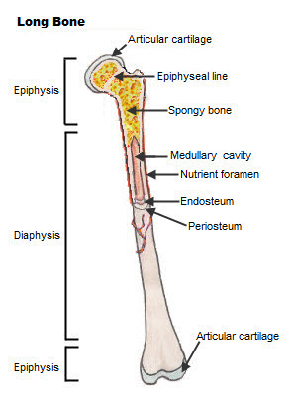

The bones of the body come in a variety of sizes and shapes. The four principal types of bones are long, short, flat and irregular. Bones that are longer than they are wide are called long bones. They consist of a long shaft with two bulky ends or extremities. They are primarily [compact bone](https://api.seer.cancer.gov/rest/glossary/latest/id/5508c482e4b0c48f31d85c28) but may have a large amount of spongy [bone](https://api.seer.cancer.gov/rest/glossary/latest/id/5504d0d3e4b0c48f31d6d9e2) at the ends or extremities. Long bones include bones of the thigh, leg, arm, and forearm.

**b. Short Bones**

Short bones are roughly cube shaped with vertical and [horizontal](https://api.seer.cancer.gov/rest/glossary/latest/id/55021cdbe4b0c48f31d617c1) dimensions approximately equal. They consist primarily of spongy bone, which is covered by a thin layer of compact bone. Short bones include the bones of the wrist and ankle.

**c. Flat Bones**

Flat bones are thin, flattened, and usually curved. Most of the bones of the [cranium](https://api.seer.cancer.gov/rest/glossary/latest/id/546cf5c1e4b0d965832a94ce) are flat bones.

**d. Irregular Bones**

Bones that are not in any of the above three categories are classified as irregular bones. They are primarily spongy bone that is covered with a thin layer of compact bone. The vertebrae and some of the bones in the [skull](https://api.seer.cancer.gov/rest/glossary/latest/id/546cf5c1e4b0d965832a94ce) are irregular bones.

All bones have surface markings and characteristics that make a specific bone unique. There are holes, depressions, smooth facets, lines, projections and other markings. These usually represent passageways for vessels and nerves, points of [articulation](https://api.seer.cancer.gov/rest/glossary/latest/id/555fcdf7e4b0f29f1c05d3ec) with other bones or points of attachment for tendons and ligaments.

**3.4. Structure of bone tissue**

**a. cells**

Bones are not a static tissue but need to be constantly maintained and remodeled. There are three main cell types involved in this process.

**b. Osteoblasts:** These are responsible for making new bone and repairing older bone. Osteoblasts produce a protein mixture called osteoid, which is mineralized and becomes bone. They also manufacture hormones, including prostaglandins.

**c. :** These are inactive osteoblasts that have become trapped in the bone that they have created. They maintain connections to other osteocytes and osteoblasts. They are important for communication within bone tissue.

**d. Osteoclasts:** These are large cells with more than one nucleus. Their job is to break down bone. They release enzymes and acids to dissolve minerals in bone and digest them. This process is called resorption. Osteoclasts help remodel injured bones and create pathways for nerves and blood vessels to travel through.

**e. Bone marrow**

Bone marrow is found in almost all bones where cancellous bone is present.

The marrow is responsible for making around 2 million red blood cells every second. It also produces lymphocytes or the white blood cells involved in the immune response.

1. **Extracellular matrix**

Bones are essentially living cells embedded in a mineral-based organic matrix. This extracellular matrix is made of:

1. **Organic components**, being mostly type 1 collagen.
2. **Inorganic components**, including hydroxyapatite and other salts, such as calcium and phosphate.

Collagen gives bone its tensile strength, namely the resistance to being pulled apart. Hydroxyapatite gives the bones compressive strength or resistance to being compressed.

**3.5. Bone Growth**

Bones grow in length at the epiphyseal plate by a process that is similar to endochondral ossification. The cartilage in the region of the epiphyseal plate next to the epiphysis continues to grow by [mitosis](https://api.seer.cancer.gov/rest/glossary/latest/id/546e3809e4b0d965832b36e4). The chondrocytes, in the region next to the diaphysis, age and degenerate. Osteoblasts move in and ossify the matrix to form bone. This process continues throughout childhood and the adolescent years until the cartilage growth slows and finally stops. When cartilage growth ceases, usually in the early twenties, the epiphyseal plate completely ossifies so that only a thin [epiphyseal line](https://api.seer.cancer.gov/rest/glossary/latest/id/55a1ab81e4b05cd0cdd90a7a) remains and the bones can no longer grow in length. Bone growth is under the influence of [growth hormone](https://api.seer.cancer.gov/rest/glossary/latest/id/5504328fe4b0c48f31d6c1f3) from the [anterior](https://api.seer.cancer.gov/rest/glossary/latest/id/55021d54e4b0c48f31d61808) [pituitary gland](https://api.seer.cancer.gov/rest/glossary/latest/id/542eee9f102c1d14697ef812) and sex hormones from the ovaries and testes.

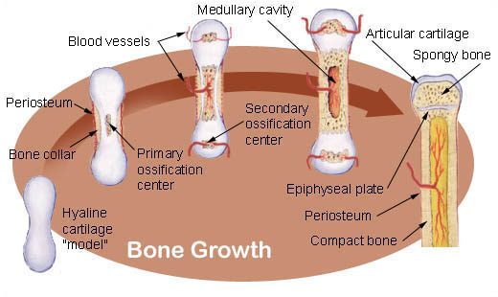

Even though bones stop growing in length in early adulthood, they can continue to increase in thickness or [diameter](https://api.seer.cancer.gov/rest/glossary/latest/id/5522a23de4b0bc5c16c02a42) throughout life in [response](https://api.seer.cancer.gov/rest/glossary/latest/id/55523c3be4b0426fced8d697) to [stress](https://api.seer.cancer.gov/rest/glossary/latest/id/55a93bd9e4b05cd0cddc432a) from increased [muscle](https://api.seer.cancer.gov/rest/glossary/latest/id/55a2f6a5e4b05cd0cdd944ea) activity or to weight. The increase in diameter is called appositional growth. Osteoblasts in the periosteum form compact bone around the [external](https://api.seer.cancer.gov/rest/glossary/latest/id/55022533e4b0c48f31d6204b) bone surface. At the same time, osteoclasts in the [endosteum](https://api.seer.cancer.gov/rest/glossary/latest/id/55a1a966e4b05cd0cdd9092f) break down bone on the [internal](https://api.seer.cancer.gov/rest/glossary/latest/id/55022573e4b0c48f31d62074) bone surface, around the medullary cavity. These two processes together increase the diameter of the bone and, at the same time, keep the bone from becoming excessively heavy and bulky.

**3.6. Common disorders of skeletal systems**

**a. Osteoporosis**

 Is an age-related disorder in which bones lose mass, weaken, and break more easily than normal bones. Bones may weaken so much that a fracture can occur with minor stress — or even spontaneously, without any stress at all.

Osteoporosis is the most common cause of broken bones in the elderly, but until a bone fracture occurs, it typically causes no symptoms.

**b. Osteoarthritis**

**(OA)** is a Joint disease that results from the breakdown of joint cartilage

 and bone. The most common symptoms are joint pain and stiffness. Other symptoms may include joint swelling and decreased range of motion. Initially, symptoms may occur only after exercise or prolonged activity, but over time, they may become constant, negatively affecting work and normal daily activities. As shown in Figure 14.7.514.7.5, the most commonly involved joints are those near the ends of the fingers, at the bases of the thumbs, and in the neck, lower back, hips, and knees. Often, joints on one side of the body are affected more than those on the other side.

**c. Paget's Disease**

This skeletal disease causes new bone tissue to grow too rapidly, which causes bones to become misshapen or fragile.  This also makes them more susceptible to easy breakage or fractures.  Paget's disease more frequently occurs in older patients and in patients who have the disease in their family history.  It commonly affects the bones in the spine, pelvis, skull, and legs.  Bone pain is the most common complaint in patients with Paget's disease.

**d. Rickets**

Rickets, a bone disease that affects children, is the weakening of bones caused by a vitamin D deficiency.  When children have a lack of vitamin D, they are unable to fully absorb calcium and other nutrients essential to building bone density and mass.  This leads to a softening or weakening of the bone structure overall, which can cause easy breaks and fractures.  Typically, when you supplement a child's diet with vitamin D, you will often correct this issue.

**e.Hip Dysplasia**

Hip dysplasia is often diagnosed early in infancy when physicians notice that the hip socket has not been fully formed around the upper thighbone.  This can cause pain if neglected, because over time the tissue will erode, and bone will be resting on bone.  Hip dysplasia can cause hips to be easily dislocated.  When diagnosed in infancy, hip dysplasia can often be corrected with a soft brace.  However, if detected later in life, it may require surgery to adjust any bones and provide proper movement.

These four diseases of the skeletal system can affect patients of any age, and are generally treatable to different extents.  If you are suffering from a skeletal disease like one of the above, contact an orthopedic surgeon in Deland to get the best patient care and treatment for you.  [Call](https://www.floridaboneandjoint.com/contact.html)Florida Bone and Joint Specialists today to schedule an appointment with our excellent team of doctors.

**6.0. Cardiovascular system**

Your heart and blood vessels, the parts of the cardiovascular system, are important because they bring oxygen, nutrients and other good things to every cell in your body. They also take away carbon dioxide and waste. This supply of nutrients and the removal of waste is the main function of the cardiovascular system.

**4.1. Structure and physiology of heart**

**What is the heart?**

The heart weighs around 350g and is roughly the size of an adult’s clenched fist. It is enclosed in the mediastinal cavity of the thorax between the lungs, and extends downwards on the left between the second and fifth intercostal space . If one draws an imaginary line from the middle of the left clavicle down to below the nipple, this is where the most forceful part of the heart, the apex beat, can be felt.

The heart is enclosed in a sac, the pericardium, which protects it and prevents it from over-expanding, anchoring it inside the thorax. The pericardium is attached to the diaphragm and inner surface of the sternum, and is made up of:

* The fibrous pericardium, composed of a loosely fitting but dense layer of connective tissue;
* The serous pericardium or epicardium, composed of the parietal and visceral layers;
* A film of serous fluid between the fibrous and serous pericardium that allows them to glide smoothly against each other.
  1. **Atria and ventricles**

The atria receive blood returning to the heart, while the ventricles receive blood from the atria – via the atrioventricular valves – and pumps it into the lungs and the rest of the body (Fig 2a). The left atrium (LA) and left ventricle (LV) are separated from the right atria (RA) and right ventricle (RV) by a band of tissue called the septum.

The RA receives deoxygenated blood from the head and neck and from the rest of the body via the superior and inferior vena cava, respectively. The RV then pumps blood into the lungs (through the pulmonary trunk, which divides into the right and left pulmonary arteries), where it is oxygenated. The oxygenated blood is returned to the LA via the pulmonary veins and passes into the LV through the cardiac valves. From the LV, it is delivered to the whole body through the aorta.

The RV does not need a huge amount of force to pump blood into the lungs, compared with the LV, which has to pump blood into the rest of the body. The LV has a thicker wall and its cavity is circular, while the RV cavity is crescent-shaped with a thinner wall (Marieb and Hoehn, 2015).

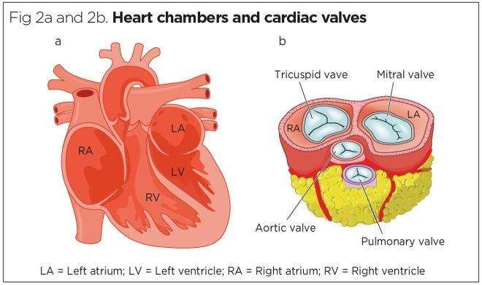

**ii. Cardiac valves**

When working correctly, the cardiac valves (Fig 2b) ensure a one-way system of blood flow. They have projections (cusps) held in place by strong tendons (chordae tendinae) attached to the inner walls of the heart by small papillary muscles.

The RA and RV are separated by the tricuspid valve, which has three leaflets. The tricuspid valve allows deoxygenated blood to move from the RA into the RV. From the RV, blood passes through the pulmonary valve (situated between the RV and the pulmonary artery), allowing deoxygenated blood to enter the lungs.

On the left side of the heart, oxygenated blood from the lungs enters the LA from the pulmonary vein. The LA is separated from the LV by the mitral valve (also called bicuspid valve, as it has two leaflets (Fig 2b)) and blood flows through this valve into the LV. It then passes through the aortic valve into the aorta, which transports oxygenated blood throughout the body.

1. **Coronary circulation**

The heart itself requires a richly oxygenated blood supply to support its activity. This is delivered via the right and left coronary arteries, which lie on the epicardium and penetrate the myocardium with deeper branches to supply this highly active layer of muscle.

The right and left coronary arteries arise from vascular openings at the base of the aorta, called the coronary ostia. The left coronary artery runs towards the left side of the heart, dividing into the left anterior descending artery and the left circumflex artery. The right coronary artery runs down the right side of the heart dividing into the marginal artery (lateral part of the right-hand side of the heart) and posterior descending artery (supplying the posterior part of the heart) (Fig 3).

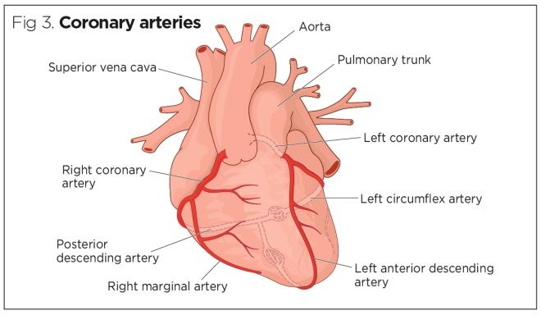

The coronary arteries provide an intermittent supply of blood to the heart, predominantly when the heart is relaxed (during diastole), as the entrance to the coronary arteries is open at that point of the cardiac cycle. Table 1 shows which regions of the heart are supplied by which coronary arteries.

**4.2. Structure and functions of blood vessels**

Blood is transported in arteries, veins and capillaries.

Blood is pumped from the heart in the arteries. It is returned to the heart in the veins.

The capillaries connect the two types of blood vessel and molecules are exchanged between the blood and the cells across their walls.

Arteries carry blood away from the heart

| **Arteries** | **Veins** |
| --- | --- |
| Always carry blood **away** from the heart | Always carry blood **to** the heart |
| Carry oxygenated blood, except for the pulmonary artery | Always carry deoxygenated blood, except for the pulmonary vein |
| Carry blood under high pressure | Carry blood under low or negative pressure |
| Have thick muscular and elastic walls to pump and accommodate blood | Have thin walls - have less muscular tissue than arteries |
| A type of supporting tissue called connective tissue provides strength | Have less connective tissue than arteries |
| The channel in the blood vessel that carries blood - the **lumen** - is narrow | Have a wide lumen |

Veins contain valves which prevent the backflow of blood.

Cross-section through valve

**4.3. Controlling blood flow**

In order to control blood flow through the vessels, the smooth muscle surrounding the arteries can constrict which causes vasoconstriction or they can relax which causes vasodilation.

**4.4. Blood**

Is a combination of plasma and cells that circulate through the body. It supplies essential substances, such as sugars, oxygen, and hormones, to cells and organs, and removes waste from cells.

[Hematologists](https://www.medicalnewstoday.com/articles/hematology) work to identify and prevent blood and [bone marrow](https://www.medicalnewstoday.com/articles/285666.php) diseases. They also study and treat the immune system, blood clotting, and blood vessels.

Health conditions that affect the blood can be life threatening, but effective treatment is often available. In the United States, blood diseases accounted for [10,066Trusted Source](https://www.nhlbi.nih.gov/files/docs/research/2012_ChartBook_508.pdf) deaths in 2008, mostly different types of anemia.

1. **Components of blood**

The main [components](https://www.redcrossblood.org/donate-blood/how-to-donate/types-of-blood-donations/blood-components.html) of blood are:

* plasma
* red blood cells
* white blood cells
* platelets

Plasma accounts for around [55%](http://www.redcrossblood.org/learn-about-blood/blood-components) of blood fluid in humans. Plasma is 92% water, and the contents of the remaining 8% include:

* glucose
* hormones
* proteins
* mineral salts
* fats
* [vitamins](https://www.medicalnewstoday.com/articles/195878.php)

The remaining 45% of blood mainly consists of red and white blood cells and platelets. Each of these has a vital role to play in keeping the blood functioning effectively.

1. **Red blood cells, or erythrocytes**

Red blood cells have a slightly indented, flattened disk shape. They transport oxygen to and from the lungs. Hemoglobin is a protein that contains iron and carries oxygen to its destination. The life span of a red blood cell is 4 months, and the body replaces them regularly. The human body produces around [2 millionTrusted Source](https://www.ncbi.nlm.nih.gov/pmc/articles/PMC4717490/) blood cells every second.

The expected number of red blood cells in a single drop (microliter) of blood is [4.5–6.2 million](https://uihc.org/health-library/complete-blood-count-guide-patients-cancer) in males and 4.0–5.2 million in females.

1. **White blood cells, or leukocytes**

[White blood cells](https://www.medicalnewstoday.com/articles/327446) make up [less than 1%](http://www.redcrossblood.org/learn-about-blood/blood-components/white-blood-cells-and-granulocytes) of blood content, forming vital defenses against disease and infection. The number of white blood cells in a microliter of blood usually ranges from [3,700–10,500](https://uihc.org/health-library/complete-blood-count-guide-patients-cancer). Higher or lower levels of white blood cells can indicate disease.

1. **Platelets, or thrombocytes**

Platelets interact with clotting proteins to prevent or stop bleeding. There should be between [150,000 and 400,000](https://uihc.org/health-topics/complete-blood-count-guide-patients-cancer) platelets per microliter of blood.

Bone marrow produces red blood cells, white blood cells, and platelets, and from there they enter the bloodstream. Plasma is mostly water that is absorbed from ingested food and fluid by the intestines. The heart pumps them around the body as blood by way of the blood vessels.

1. **Functions blood**

Blood has various functions that are central to survival. They include:

* supplying oxygen to cells and tissues
* providing essential nutrients to cells, such as amino acids, fatty acids, and glucose
* removing waste materials, such as carbon dioxide, urea, and lactic acid
* protecting the body from diseases, infections, and foreign bodies through the action of white blood cells
* regulating body temperature

The platelets in blood enable the clotting, or coagulation, of blood. When bleeding occurs, the platelets group together to create a clot. The clot forms a scab, which stops the bleeding and helps protect the wound from infection.

1. **Blood groups**

A person’s blood type is [determined](https://www.nhs.uk/conditions/blood-groups/) by the antigens on the red blood cells. Antigens are protein molecules on the surface of these cells.

Antibodies are proteins in plasma that alert the immune system to the presence of potentially harmful foreign substances. The immune system protects the body from the threat of disease or infection.

Knowing a person’s blood type is essential if they are receiving an organ donation or blood transfusion. Antibodies will attack new blood cells if the blood is the wrong type, leading to life threatening complications. For example, anti-A antibodies will attack cells that have A antigens.

Red blood cells sometimes contain another antigen called RhD. Doctors also note this as part of the blood group. A positive blood group means that RhD is present.

Humans can have one of four main blood groups. Each of these groups can be Rhd-positive or -negative, forming eight main categories.

* **Group A positive or A negative:** A antigens are present on the surfaces of blood cells. Anti-B antibodies are present in the plasma.
* **Group B positive or B negative:** B antigens are present on the surfaces of blood cells. Anti-A antibodies are present in the plasma.
* **Group AB positive or AB negative:** A and B antigens are present on the surfaces of blood cells. There are no antibodies in the plasma.
* **Group O positive and O negative:** There are no antigens on the surfaces of blood cells. Both anti-B and anti-A antibodies are present in the plasma.

People with group O blood can donate to virtually any blood type, and people with group AB+ blood can usually receive blood from any group.

People can talk with their doctor to find out their blood type or find out by donating blood.

Blood groups are important during pregnancy. If a pregnant person has RhD-negative blood, for example, but the fetus inherits RhD-positive blood, treatment will be necessary to [preventTrusted Source](https://www.nhlbi.nih.gov/health-topics/rh-incompatibility) a condition known as hemolytic disease of the newborn.

**4.5. Diseases that can affect the circulatory system include:**

**1. Atherosclerosis**

[Atherosclerosis](https://www.medicalnewstoday.com/articles/247837.php) is a hardening of the arteries.

It is typically caused by a diet high in fat, which leaves fatty deposits on the lining of the blood vessels. These fatty deposits stick together and make the arteries hard and less flexible.

Atherosclerosis leads to [high blood pressure](https://www.medicalnewstoday.com/articles/159283.php), which can damage the heart and kidneys and even lead to [strokes](https://www.medicalnewstoday.com/articles/7624.php).

**2. Heart attack**

Myocardial infarction (MI) is the technical term for a [heart attack](https://www.medicalnewstoday.com/articles/151444.php). A heart attack can occur when the blood supply is cut off from the heart, often by a blood clot. Some heart attacks are minor, but others can be life-threatening.

**3. Mitral valve prolapse**

Mitral valve prolapse means the mitral valve bulges out or prolapses because it does not close evenly. The mitral valve pumps freshly oxygenated blood out of the heart to the rest of the body.

**4. Mitral valve regurgitation**

Mitral valve regurgitation happens when the mitral valve does not close all the way and causes a leak, allowing some of the oxygenated blood to flow backward.

**5. Mitral stenosis**

Mitral stenosis means the mitral valve is abnormally narrow which can prevent the blood from flowing smoothly or quickly through it.

**6. Angina pectoris**

[Angina](https://www.medicalnewstoday.com/articles/8886.php) pectoris means “pain in the chest” and occurs if the heart is not receiving enough blood. People often describe it as a crushing sensation or feeling like their chest is in a vice.

People with angina pectoris may also feel breathless, tired, and nauseated.

**7. Arrhythmia and dysrhythmia**

[Arrhythmia](https://www.medicalnewstoday.com/articles/8887.php) and dysrhythmia are often used interchangeably, and both refer to abnormal heart rates and rhythms. In general, arrhythmia means “no rhythm” and dysrhythmia means “abnormal rhythm.”

**8. Cardiac Ischemia**.

Cardiac ischemia means the heart muscle is not getting enough oxygen to function properly. A person with cardiac ischemia will usually experience angina-like pain and may feel as though they are having a heart attack.

**9. High cholesterol**

High [cholesterol](https://www.medicalnewstoday.com/articles/9152.php) is usually caused by a sedentary lifestyle and an unhealthful diet. Some people can also be genetically at risk of high cholesterol.

People need cholesterol, but too much cholesterol can form a thick layer on the inside of the vessels, blocking blood flow.

**10. Heart failure**

[Heart failure](https://www.medicalnewstoday.com/articles/156849.php) means that the heart is not pumping blood around the body as efficiently as it should. It can lead to [fatigue](https://www.medicalnewstoday.com/articles/248002.php), shortness of breath, and coughing.

Some people with heart failure find it difficult to do things such as walking, climbing stairs, or carrying groceries.

**11. High blood pressure (hypertension)**

High blood pressure or [hypertension](https://www.medicalnewstoday.com/articles/150109.php) means the force or pressure of the blood flowing through the vessels is consistently too high. High blood pressure can lead to stroke, loss of vision, heart failure, heart attack, kidney disease, and reduced sexual function.

**12. Stroke**

A stroke can happen when one of the vessels that lead to the brain either becomes blocked by a blood clot or bursts. This stops blood flow and prevents oxygen from getting to the brain.

**13. Peripheral artery disease (PAD)**

[Peripheral artery disease](https://www.medicalnewstoday.com/articles/188939.php) (PAD) refers to narrowing of the arteries that lead to the legs, stomach, arms, and head. This reduced blood flow can damage the cells and tissues in the limbs, organs, and brain. PAD tends to occur more often in older people.

**14. Venous thromboembolism (VTE)**

Venous thromboembolism (VTE) is a blood clot that gets stuck in a vein, blocking the flow of blood. It is a serious condition that needs emergency medical attention.

**15. Aortic aneurysms**

Aortic [aneurysms](https://www.medicalnewstoday.com/articles/156993.php) affect the main artery in the body. It means the artery wall has weakened, allowing it to widen or “balloon out.” An enlarged artery could burst and become a medical emergency

**7.0. Lymphatic system**

**5.1. Structure and functions of lymphatic system**

The lymphatic system is a subsystem of the circulatory system in the vertebrate body that consists of a complex network of vessels, tissues, and organs. It helps maintain fluid balance in the body by collecting excess fluid and particulate matter from tissues and depositing them in the bloodstream.

5.1.1. 5.1.1. **Structure of the Lymphatic System**

The lymphatic system consists of lymphatic vessels and associated lymphoid organs.

The lymphatic system is a collection of structures and vessels that drains lymph from blood and has several other functions. It is a circulatory system for lymph fluid and the site of many key immune system functions.

* 1. **Lymphatic Vessels**

The lymphatic vessels are the lymphatic system equivalent of the blood vessels of the circulatory system and drain fluid from the circulatory system. The network of lymph vessels consists of the initial collectors of lymph fluid, which are small, valveless vessels, and goes on to form the precollector vessels, which have rudimentary valves that are not fully functional. These structures then form increasingly larger lymphatic vessels which form colaterals and have lymph-angions (lymph hearts).  The larger lymph vessels contain valves that prevent the backflow of lymph.

The lymphatic system is an active pumping system driven by segments that have a function similar to peristalsis. They lack a central pump (like the heart in the cardio vascular system), so smooth muscle tissue contracts to move lymph along through the vessels. Skeletal muscle contractions also move lymph through the vessels. The lymphatic vessels make their way to the lymph nodes, and from there the vessels form into trunks. In general, the lymph vessels bring lymph fluid toward the heart and above it to the subclavian veins, which enable lymph fluid to re-enter the circulatory system through the vena cava.

1. **Lymphatic Tissues and Organs**

Lymphoid tissue is found in many organs including the lymph nodes, as well as in the lymphoid follicles in the pharynx such as the tonsils. Lymph nodes are found primarily in the armpits, groin, chest, neck, and abdomen. Lymphoid tissues contain lymphocytes (a type of highly differentiated white blood cell), but they also contain other types of cells for structural and functional support, such as the dendritic cells, which play a key role in the immune system. The system also includes all the structures dedicated to the circulation and production of lymphocytes, including the spleen, thymus, and bone marrow.

**5.3.Functions of the Lymphatic System**

The lymphatic system plays a prominent role in immune function, fatty acid absorption, and removal of interstitial fluid from tissues.

The lymphatic system is the site of many key immune system functions. It is important to distinguish that immune system functions can happen almost anywhere in the body, while the lymphatic system is its own system where many immune system functions take place. Besides immune system function, the lymphatic system has many functions of its own. It is responsible for the removal and filtration of interstitial fluid from tissues, absorbs and transports fatty acids and fats as chyle from the digestive system, and transports many of the cells involved in immune system function via lymph.

* 1. **Removal of Fluid**

Interstitial fluid accumulates in the tissues, generally as a result of the pressure exerted from capillaries (hydrostatic and osmotic pressure) or from protein leakage into the tissues (which occurs during inflammation). These conditions force fluid from the capillaries into the tissues. One of the main functions of the lymphatic system is to drain the excess interstitial fluid that accumulates.

The lymphatic system is a blunt-ended linear flow system, in which tissue fluids, cells, and large extracellular molecules, collectively called lymph, are drained into the initial lymphatic capillary vessels that begin at the interstitial spaces of tissues and organs. They are then transported to thicker collecting lymphatics, which are embedded with multiple lymph nodes, and are eventually returned to the blood circulation through the left and right subclavian veins and into the vena cava. They drain into venous circulation because there is lower blood pressure in veins, which minimizes the impact of lymph cycling on blood pressure. Lymph nodes located at junctions between the lymph vessels also filter the lymph fluid to remove pathogens and other abnormalities.

Fluid removal from tissues prevents the development of edema. Edema is any type of tissue swelling from increased flow of interstitial fluid into tissues relative to fluid drainage. While edema is a normal component of the inflammation process, in some cases it can be very harmful. Cerebral and pulmonary edema are especially problematic, which is why lymph drainage is so important. Abnormal edema can still occur if the drainage components of the lymph vessels are obstructed.

* 1. **Fatty Acid Transport**

The lymphatic system also facilitates fatty acid absorption from the digestive system. During fat digestion, fatty acids are digested, emulsified, and converted within intestinal cells into a lipoprotein called chylomicrons. Lymph drainage vessels that line the intestine, called lacteals, absorb the chylomicrons into lymph fluid. The lymph vessels then take the chylomicrons into blood circulation, where they react with HDL cholesterols and are then broken down in the liver.

* 1. **Immune Cell Transport**

In addition to tissue fluid homeostasis, the lymphatic system serves as a conduit for transport of cells involved in immune system function. Most notably, highly-specialized white blood cells called lymphocytes and antigen -presenting cells are transported to regional lymph nodes, where the immune system encounters pathogens, microbes, and other immune elicitors that are filtered from the lymph fluid. Much of the adaptive immune system response, which is mediated by dendritic cells, takes place in the lymph nodes. Lymphatic vessels, which uptake various antigens from peripheral tissues, are positively regulated by chemokines/cytokines secreted by various immune cells during inflammation. This allows antigens to enter lymph nodes, where dendritic cells can present them to lymphocytes to trigger an adaptive immune response.

While the lymphatic system is important for transporting immune cells, its transport capabilities can also provide a pathway for the spread of cancer. Lymph circulation is one of the main ways that tumors can spread to distant parts of the body, which is difficult to prevent.

**5.4. Disorders of lymphatic system**

1. **Hodgkin's Disease/Hodgkin's Lymphoma** [Hodgkin lymphoma](https://en.wikipedia.org/wiki/Hodgkin_lymphoma) This is a type of cancer of the lymphatic system. It can start almost anywhere in the body. It is believed to be caused by [HIV](https://en.wikipedia.org/wiki/HIV), [Epstein-Barr Syndrome](https://en.wikipedia.org/wiki/Epstein-Barr_Syndrome), age, and family history. Symptoms include weight gain, fever, swollen [lymph nodes](https://en.wikipedia.org/wiki/Lymph_node), night sweats, itchy skin, fatigue, chest pain, coughing, or trouble swallowing.

**2. Non-Hodgkin's Lymphoma**

Lymphoma is usually malignant cancer. It is caused by the body producing too many abnormal [white blood cells](https://en.wikipedia.org/wiki/White_blood_cell). It is not the same as Hodgkin's Disease. Symptoms usually include painless, enlarged lymph node or nodes in the neck, weakness, fever, weight loss, and anemia

* 1. **Lymphadenitis**

Lymphadenitis is an infection of the lymph nodes usually caused by a virus, bacteria or fungi. Symptoms include redness or swelling around the lymph node\]

* 1. **Lymphangitis**

Lymphangitis is an inflammation of the lymph vessels. Symptoms usually include swelling, redness, warmth, pain or red streaking around the affected area\

* 1. **Lymphedema**

Lymphedema is the chronic pooling of [lymph fluid](https://en.wikipedia.org/wiki/Lymph_fluid) in the tissue. It usually starts in the feet or lower legs. It's also a side-effect of some surgical procedures\]

* 1. **Lymphocytosis**

Lymphocytosis is a high lymphocyte count. It can be caused by an infection, blood cancer, lymphoma, or autoimmune disorders that are accompanied by chronic swelling\

**7.0. Endocrine System**

The endocrine system is a network of [glands](https://www.healthline.com/health/what-are-glands) and organs located throughout the body. It’s similar to the [nervous system](https://www.healthline.com/human-body-maps/nervous-system#1) in that it plays a vital role in controlling and regulating many of the body’s functions.

However, while the nervous system uses nerve impulses and neurotransmitters for communication, the endocrine system uses chemical messengers called hormones.

# Classification of endocrine systemDifference between Endocrine and Exocrine Glands

The human body has many glands which produce many secretions, such as sweat, saliva, oil and hormones. Anatomically, these glands are broadly classified into two types based on the presence or absence of ducts. Endocrine glands are the glands that secrete hormones without ducts, while exocrine glands secrete hormones through ducts. Read on to explore more differences between the two.

|  |  |
| --- | --- |
| Difference Between Exocrine Glands and Endocrine Glands | |
| Endocrine Glands | Exocrine Glands |
| Ducts | |
| Endocrine glands do not have ducts. | Exocrine glands have ducts. |
| Secretory Products | |
| Hormones | Sweat, enzymes, mucus, sebum |
| Route of Secretion | |
| Secretory products are released directly into the bloodstream, eventually reaching the target organ. | Secretory products are released to an internal organ or the external surface through a duct. |
| Examples | |
| Thyroid glands, parathyroid glands, pituitary glands, adrenal glands. | Salivary glands, liver, Brunner’s glands, oesophageal glands. |

**6.1. Endocrine system function**

The endocrine system is responsible for regulating a range of bodily functions through the release of hormones.

Hormones are secreted by the glands of the endocrine system, traveling through the bloodstream to various organs and tissues in the body. The hormones then tell these organs and tissues what to do or how to function.

Some examples of bodily functions that are controlled by the endocrine system include:

* metabolism
* growth and development
* sexual function and reproduction
* heart rate
* blood pressure
* appetite
* sleeping and waking cycles
* body temperature

**6.2. Endocrine system organs**

The endocrine system is made up of a complex network of [glands](https://www.healthline.com/health/what-are-glands), which are organs that secrete substances.

The glands of the endocrine system are where hormones are produced, stored, and released. Each gland produces one or more hormones, which go on to target specific organs and tissues in the body.

The glands of the endocrine system include:

* **Hypothalamus.** While some people don’t consider it a gland, the [hypothalamus](https://www.healthline.com/human-body-maps/hypothalamus) produces multiple hormones that control the pituitary gland. It’s also involved in regulating many functions, including sleep-wake cycles, body temperature, and appetite. It can also regulate the function of other endocrine glands.
* **Pituitary.** The [pituitary gland](https://www.healthline.com/human-body-maps/pituitary-gland) is located below the hypothalamus. The hormones it produces affect growth and reproduction. They can also control the function of other endocrine glands.
* **Pineal.** This [gland](https://www.healthline.com/health/pineal-gland-function) is found in the middle of your brain. It’s important for your sleep-wake cycles.
* **Thyroid.**The [thyroid gland](https://www.healthline.com/human-body-maps/thyroid-gland#1) is located in the front part of your neck. It’s very important for metabolism.
* **Parathyroid**. Also located in the front of your neck, the parathyroid gland is important for maintaining control of calcium levels in your bones and blood.
* **Thymus.** Located in the upper torso, the [thymus](https://www.healthline.com/human-body-maps/thymus#1) is active until puberty and produces hormones important for the development of a type of white blood cell called a T cell.
* **Adrenal.** One [adrenal gland](https://www.healthline.com/health/adrenal-glands) can be found on top of each kidney. These glands produce hormones important for regulating functions such as blood pressure, heart rate, and stress response.
* **Pancreas.**The [pancreas](https://www.healthline.com/human-body-maps/pancreas#1) is located in your abdomen behind your stomach. Its endocrine function involves controlling blood sugar levels.

Some endocrine glands also have non-endocrine functions. For example, the ovaries and testes produce hormones, but they also have the non-endocrine function of producing [eggs](https://www.healthline.com/health/womens-health/follicular-phase) and [sperm](https://www.healthline.com/health/how-is-sperm-produced), respectively.

**6.3. Endocrine system hormones**

Hormones are the chemicals the endocrine system uses to send messages to organs and tissue throughout the body. Once released into the bloodstream, they travel to their target organ or tissue, which has receptors that recognize and react to the hormone.

Below are some examples of hormones that are produced by the endocrine system.

|  |  |  |
| --- | --- | --- |
| **Hormone** | **Secreting gland(s)** | **Function** |
| adrenaline | adrenal | increases blood pressure, heart rate, and metabolism in reaction to stress |
| aldosterone | adrenal | controls the body’s salt and water balance |
| cortisol | adrenal | plays a role in stress response |
| dehydroepiandrosterone sulfate (DHEA) | adrenal | aids in production of body odor and growth of body hair during puberty |
| estrogen | ovary | works to regulate [menstrual cycle](https://www.healthline.com/health/womens-health/stages-of-menstrual-cycle), maintain pregnancy, and develop female sex characteristics; aids in sperm production |
| follicle stimulating hormone (FSH) | pituitary | controls the production of eggs and sperm |
| glucagon | pancreas | helps to increase levels of blood glucose |
| insulin | pancreas | helps to reduce your blood glucose levels |
| luteinizing hormone (LH) | pituitary | controls estrogen and testosterone production as well as ovulation |
| melatonin | pineal | controls sleep and wake cycles |
| oxytocin | pituitary | helps with lactation, childbirth, and mother-child bonding |
| parathyroid hormone | parathyroid | controls calcium levels in bones and blood |
| progesterone | ovary | helps to prepare the body for pregnancy when an egg is fertilized |
| prolactin | pituitary | promotes breast-milk production |
| testosterone | ovary, teste, adrenal | contributes to sex drive and body density in males and females as well as development of male sex characteristics |
| thyroid hormone | thyroid | help to control several body functions, including the rate of metabolism and energy levels |

**6.4. Conditions that can affect the endocrine system**

Sometimes, hormone levels can be [too high or too low](https://www.healthline.com/health/hormone-imbalance). When this happens, it can have a number of effects on your health. The signs and symptoms depend on the hormone that’s out of balance.

Here’s a look at some conditions that can affect the endocrine system and alter your hormone levels.

**1.**[**Hyperthyroidism**](https://www.healthline.com/health/hyperthyroidism) ,happens when your thyroid gland makes more thyroid hormone than necessary. This can be caused by a range of things, including autoimmune conditions.

Treatment depends on how severe the condition is, as well as its underlying cause. Options include medications, radioiodine therapy, or surgery.

[Graves disease](https://www.healthline.com/health/graves-disease) is an autoimmune disorder and common form of hyperthyroidism. In people with Graves disease, the immune system attacks the thyroid, which causes it to produce more thyroid hormone than normal.

* 1. **Hypothyroidism**

[Hypothyroidism](https://www.healthline.com/health/hypothyroidism/symptoms-treatments-more) occurs when your thyroid doesn’t produce enough thyroid hormone. Like hyperthyroidism, it has many potential causes.

Treatment of hypothyroidism involves supplementing your thyroid hormone with medication.

* 1. **Cushing syndrome**

[Cushing syndrome](https://www.healthline.com/health/cushing-syndrome) happens due to high levels of the hormone cortisol.

Treatment depends on the cause of the condition and can include medications, radiation therapy, or surgery.

* 1. **Addison disease**

[Addison disease](https://www.healthline.com/health/addisons-disease) happens when your adrenal glands don’t produce enough cortisol or aldosterone. Some symptoms of Addison disease include:Treatment of Addison disease involves taking medications that help to replace the hormones that your body isn’t producing enough of.

* 1. **Diabetes**

[Diabetes](https://www.healthline.com/health/diabetes) refers to a condition in which your blood sugar levels aren’t regulated properly.

People with diabetes have too much glucose in their blood (high blood sugar). There are two types of diabetes: [type 1 diabetes](https://www.healthline.com/health/type-1-diabetes-causes-symtoms-treatments) and [type 2 diabetes](https://www.healthline.com/health/type-2-diabetes).

**9.0. Excretory system**

**7.1. Kidneys**

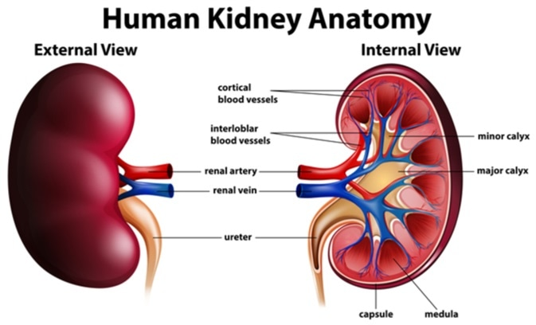

The kidneys are two bean-shaped organs in the renal system. They help the body pass waste as urine. They also help filter blood before sending it back to the heart.

The kidneys perform many crucial functions, including:

* maintaining overall fluid balance
* regulating and filtering minerals from blood
* filtering waste materials from food, medications, and toxic substances
* creating hormones that help produce red blood cells, promote bone health, and regulate blood pressure

1. **Nephrons**

Nephrons are the most important part of each kidney. They take in blood, metabolize nutrients, and help pass out waste products from filtered blood. Each kidney has about 1 million nephrons. Each has its own internal set of structures.

1. **Renal corpuscle**

After blood enters a nephron, it goes into the renal corpuscle, also called a Malpighian body. The renal corpuscle contains two additional structures:

* **The glomerulus.**This is a cluster of capillaries that absorb protein from blood traveling through the renal corpuscle.
* **The Bowman capsule.** The remaining fluid, called capsular urine, passes through the Bowman capsule into the renal tubules.

1. **Renal tubules**

The renal tubules are a series of tubes that begin after the Bowman capsule and end at collecting ducts.

Each tubule has several parts:

* **Proximal convoluted tubule.**This section absorbs water, sodium, and glucose back into the blood.
* **Loop of Henle.**This section further absorbs potassium, chloride, and sodium into the blood.
* **Distal convoluted tubule.**This section absorbs more sodium into the blood and takes in potassium and acid.

By the time fluid reaches the end of the tubule, it’s diluted and filled with urea. Urea is byproduct of protein metabolism that’s released in urine.

1. **Renal cortex**

The renal cortex is the outer part of the kidney. It contains the glomerulus and convoluted tubules.

The renal cortex is surrounded on its outer edges by the renal capsule, a layer of fatty tissue. Together, the renal cortex and capsule house and protect the inner structures of the kidney.

1. **Renal medulla**

The renal medulla is the smooth, inner tissue of the kidney. It contains the loop of Henle as well as renal pyramids.

1. **Renal pyramids**

Renal pyramids are small structures that contain strings of nephrons and tubules. These tubules transport fluid into the kidney. This fluid then moves away from the nephrons toward the inner structures that collect and transport urine out of the kidney.

1. **Collecting ducts**

There’s a collecting duct at the end of each nephron in the renal medulla. This is where filtered fluids exit the nephrons.

Once in the collecting duct, the fluid moves on to its final stops in the renal pelvis.

1. **Renal pelvis**

The renal pelvis is a funnel-shaped space in the innermost part of the kidney. It functions as a pathway for fluid on its way to the bladder

1. **Calyces**

The first part of the renal pelvis contains the calyces. These are small cup-shaped spaces that collect fluid before it moves into the bladder. This is also where extra fluid and waste become urine.

1. **Hilum**

The hilum is a small opening located on the inner edge of the kidney, where it curves inward to create its distinct beanlike shape. The renal pelvis passes through it, as well as the:

* **Renal artery.** This brings oxygenated blood from the heart to the kidney for filtration.
* **Renal vein.** This carries filtered blood from the kidneys back to the heart.

**Ureter**

The ureter is a tube of muscle that pushes urine into the bladder, where it collects and exits the body.

**Physiology of Urine formation**

There are three stages involved in the process of urine  formation. They are-  
1. Glomerular filtration or ultra-filtration

2. Selective reabsorption

3. Tubular secretion

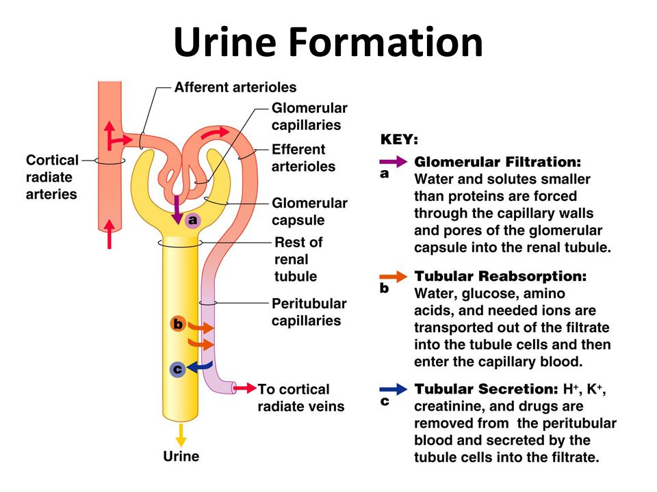

**Glomerular filtration**

* This takes place through the semipermeable walls of the glomerular capillaries and Bowman’s capsule.
* The afferent arterioles supplying blood to glomerular capsule carries useful as well as harmful substances. The useful substances are glucose, aminoacids, vitamins, hormones, electrolytes, ions etc and the harmful substances are metabolic wastes such as urea, uric acids, creatinine, ions, etc.
* The diameter of efferent arterioles is narrower than afferent arterioles. Due to this difference in diameter of arteries, blood leaving the glomerulus creates the pressure known as hydrostatic pressure.
* The **glomerular hydrostatic pressure** forces the blood to leaves the glomerulus resulting in filtration of blood. A capillary hydrostatic pressure of about 7.3 kPa (55 mmHg) builds up in the glomerulus. However this pressure is opposed by the **osmotic pressure** of the blood, provided mainly by plasma proteins, about 4 kPa (30 mmHg), and by **filtrate hydrostatic pressure** of about 2 kPa (15 mmHg in the glomerular capsule.
* The **net filtration pressure**is,

Therefore: 55-(30 +15) = 10mmHg.

* By the net filtration pressure of 10mmHg, blood is filtered in the glomerular capsule.
* Water and other small molecules readily pass through the filtration slits but Blood cells, plasma proteins and other large molecules are too large to filter through and therefore remain in the capillaries.
* The filtrate containing large amount of water, glucose, aminoacids, uric acid, urea, electrolytes etc in the glomerular capsule is known as nephric filtrate of glomerular filtrate.
* The volume of filtrate formed by both kidneys each minute is called the **glomerular filtration rate (GFR).** In a healthy adult the GFR is about 125 mL/min, i.e. 180 litres of filtrate are formed each day by the two kidneys

**Selective reabsorption**

* As the filtrate passes to the renal tubules, useful substances including some water, electrolytes and organic nutrients such as glucose, aminoacids, vitamins hormones etc are selectively reabsorbed from the filtrate back into the blood in the proximal convoluted tubule.
* Reabsorption of some substance is passive, while some substances are actively transported. Major portion of water is reabsorbed by Osmosis.
* Only 60–70% of filtrate reaches the Henle loop. Much of this, especially water, sodium and chloride, is reabsorbed in the loop, so that only 15–20% of the original filtrate reaches the distal convoluted tubule, More electrolytes are reabsorbed here, especially sodium, so the filtrate entering the collecting ducts is actually quite dilute.
* The main function of the collecting ducts is to reabsorb as much water as the body needs.
* Nutrients such as glucose, amino acids, and vitamins are reabsorbed by active transport. Positive charged ions ions are also reabsorbed by active transport while negative charged ions are reabsorbed most often by passive transport. Water is reabsorbed by osmosis, and small proteins are reabsorbed by pinocytosis.

**Tubular secretion**

* Tubular secretion takes place from the blood in the peritubular capillaries to the filtrate in the renal tubules and can ensure that wastes such as creatinine or excess H+ or excess K+ ions are actively secreted into the filtrate to be excreted.
* Excess K+ ion is secreted in the tubules and in exchange Na+ ion is reabsorbed otherwise it causes a clinical condition called Hyperkalemia.
* Tubular secretion of hydrogen ions (H+) is very important in maintaining normal blood pH.
* Substances such as , e.g. drugs including penicillin and aspirin, may not be entirely filtered out of the blood because of the short time it remains in the glomerulus. Such substances are cleared by secretion from the peritubular capillaries into the filtrate within the convoluted tubules.
* The tubular filtrate is finally known as urine. Human urine is usually hypertonic.

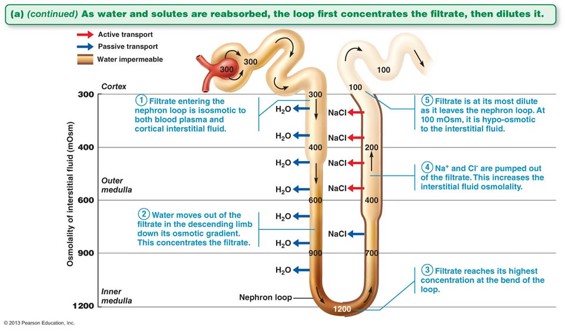

**9.2. Kidney functions**

**The 7 functions of the kidneys**

* A - Controlling ACID-base balance.
* W - Controlling WATER balance.
* E - Maintaining ELECTROLYTE balance.
* T - Removing TOXINS and waste products from the body.
* B - Controlling BLOOD PRESSURE.
* E - Producing the hormone ERYTHROPOIETIN.
* D - Activating vitamin D.

**7.3. Kidney disorders and conditions**

Because of all of the vital functions the kidneys perform and the toxins they encounter, the kidneys are susceptible to various problems.

Some of these conditions include:

* [chronic kidney disease](https://www.healthline.com/health/chronic-kidney-disease)
* [kidney failure](https://www.healthline.com/health/kidney-failure)
* [kidney stones](https://www.healthline.com/health/kidney-stones)
* [glomerulonephritis](https://www.healthline.com/health/glomerulonephritis)
* [acute nephritis](https://www.healthline.com/health/acute-nephritic-syndrome)
* [polycystic kidney disease](https://www.healthline.com/health/polycystic-kidney-disease)
* [urinary tract infections](https://www.healthline.com/health/urinary-tract-infection-adults)
* [caliectasis](https://www.healthline.com/health/kidney-health/caliectasis)
* [acidosis](https://www.healthline.com/health/acidosis)
* [uremia](https://www.healthline.com/health/uremia)
* [hydronephrosis](https://www.healthline.com/health/unilateral-hydronephrosis)
* [pyelonephritis](https://www.healthline.com/health/pyelonephritis)
* [kidney cysts](https://www.healthline.com/health/kidney-cyst)
* [nephrotic syndrome](https://www.healthline.com/health/nephrotic-syndrome)
* [azotemia](https://www.healthline.com/health/azotemia)

**10.0. Human Reproductive Anatomy**

In general, the reproductive structures in humans can be divided into three main categories:  gonads,  internal genitalia and external genitalia. The gonads are the organs in which gametes, the cells that fuse in fertilization to form new individuals, develop and mature.  All other reproductive structures are called genitalia, or genitals.  Internal genitalia are found inside of the body, while external genitalia are visible from the outside.  The structures seen in adult males and females actually come from the same precursors in embryos, so there are many similarities in both structure and function between males and females. There is also a wide spectrum of structures present in any one individual; many people have structures that resemble a combination of male and female structures, or that resemble neither. In this textbook, we will define “male” and “female” based on individuals who have the most typical structures characteristic of those two sexes; other types of structures are also normal and common. We will describe the functions of these structures during vaginal sexual intercourse, since that is the sexual act used in reproduction; keep in mind that other types of sexual activity are also common and normal.

**9.1. Male Reproductive Anatomy**

In the male reproductive system, the **scrotum** houses the testicles or testes (singular: testis), including providing passage for blood vessels, nerves, and muscles related to testicular function. The **testes** are gonads, and they produce sperm (the male gametes) and some reproductive hormones. Each testis is approximately 2.5 by 3.8 cm (1.5 by 1 in) in size and divided into wedge-shaped lobules by connective tissue called septa.

Sperm are immobile at body temperature; therefore, the scrotum and penis are external to the body, as illustrated in ***Figure 1*** so that a proper temperature is maintained for motility.

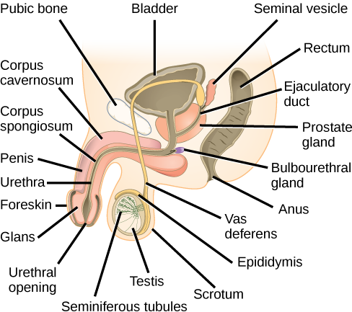**Figure**

| **Table 1. Male Reproductive Anatomy** | | |
| --- | --- | --- |
| **Organ** | **Location** | **Function** |
| Scrotum | External | Carry and support testes |
| Penis | External | Deliver urine, copulating organ |
| Seminiferous Tubules | Internal | Site of sperm maturation in testes |
| Epididymus | Internal | Part of pathway for sperm exit from body |
| Vas Deferens | Internal | Part of pathway for sperm exit from body |
| Ejaculatory Duct | Internal | Site of mixing of sperm with semen components, part of pathway for sperm exit from body |
| Testes | Internal | Produce sperm and male hormones |
| Seminal Vesicles | Internal | Contribute to semen production |
| Prostate Gland | Internal | Contribute to semen production |
| Bulbourethral Glands | Internal | Clean urethra at ejaculation |

**9.2. Female Reproductive Anatomy**

A number of reproductive structures are exterior to the female’s body. These include the breasts and the vulva, which consists of the mons pubis, clitoris, labia majora, labia minora, and the vestibular glands, all illustrated in ***Figure 3***. The location and functions of the female reproductive organs are summarized in ***Table 2***. The mons pubis is a round, fatty area that overlies the pubic bone. The **clitoris** is a structure with erectile tissue that contains a large number of sensory nerves and serves as a source of stimulation during intercourse. The **labia majora** are a pair of elongated folds of tissue that run posterior from the mons pubis and enclose the other components of the vulva. The labia majora derive from the same tissue that produces the scrotum in a male. The **labia minora** are thin folds of tissue centrally located within the labia majora. These labia protect the openings to the vagina and urethra. The mons pubis and the anterior portion of the labia majora become covered with hair during adolescence; the labia minora is hairless. The greater vestibular glands are found at the sides of the vaginal opening and provide lubrication during intercourse.The vulva is the name for the entire set of external genitalia in the inguinal (groin) area of females; in common language this is sometimes referred to as the vagina, but that is not anatomically accurate; the vagina is an entirely internal structure.

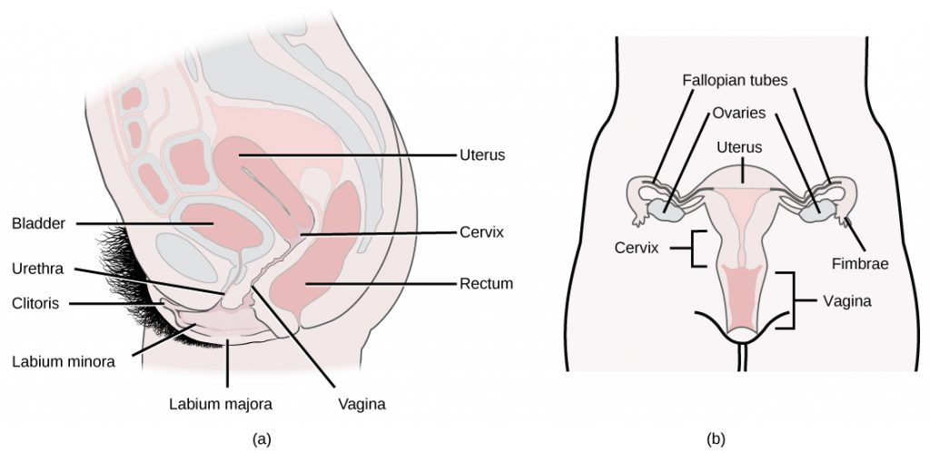**Figure 3.** The reproductive structures of the human female are shown. (credit **a**: modification of work by Gray’s Anatomy; credit **b**: modification of work by CDC)

| **Table 2. Female Reproductive Anatomy** | | |
| --- | --- | --- |
| **Organ** | **Location** | **Function** |
| Clitoris | External | Sensory organ |
| Mons pubis | External | Fatty area overlying pubic bone |
| Labia majora | External | Covers labia minora |
| Labia minora | External | Covers vestibule |
| Greater vestibular glands | External | Secrete mucus; lubricate vagina |
| Breast | External | Produce and deliver milk |
| Ovaries | Internal | Carry and develop eggs |
| Oviducts (Fallopian tubes) | Internal | Transport egg to uterus |
| Uterus | Internal | Support developing embryo |
| Vagina | Internal | Common tube for intercourse, birth canal, passing menstrual flow |

**Gametogenesis (Spermatogenesis and Oogenesis)**

Gametogenesis, the production of sperm and eggs, takes place through the process of meiosis. During meiosis, two cell divisions separate the paired chromosomes in the nucleus and then separate the chromatids that were made during an earlier stage of the cell’s life cycle, resulting in gametes that each contain half the number of chromosomes as the parent. The production of sperm is called spermatogenesis and the production of eggs is called oogenesis.

**Oogenesis**

Oogenesis occurs in the outermost layers of the ovaries. As with sperm production, oogenesis starts with a germ cell, called an oogonium (plural: oogonia), but this cell undergoes mitosis to increase in number, eventually resulting in up to one to two million cells in the embryo.

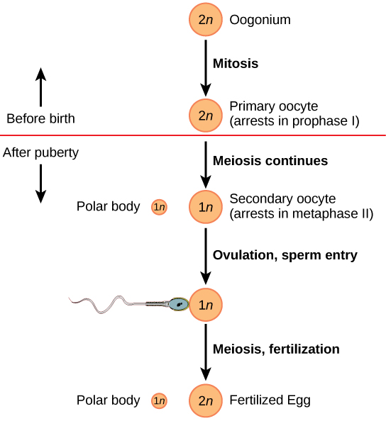Figure 43.3C.143.3�.1: Oogenesis: The process of oogenesis occurs in the ovary’s outermost layer. A primary oocyte begins the first meiotic division, but then arrests until later in life when it will finish this division in a developing follicle. This results in a secondary oocyte, which will complete meiosis if it is fertilized.

The cell starting meiosis is called a primary oocyte. This cell will begin the first meiotic division, but be arrested in its progress in the first prophase stage. At the time of birth, all future eggs are in the prophase stage. At adolescence, anterior pituitary hormones cause the development of a number of follicles in an ovary. This results in the primary oocyte finishing the first meiotic division. The cell divides unequally, with most of the cellular material and organelles going to one cell, called a secondary oocyte, and only one set of chromosomes and a small amount of cytoplasm going to the other cell. This second cell is called a polar body and usually dies. A secondary meiotic arrest occurs, this time at the metaphase II stage. At ovulation, this secondary oocyte will be released and travel toward the uterus through the oviduct. If the secondary oocyte is fertilized, the cell continues through the meiosis II, completing meiosis, producing a second polar body and a fertilized egg containing all 46 chromosomes of a human being, half of them coming from the sperm.

**Spermatogenesis**

Spermatogenesis occurs in the wall of the seminiferous tubules, with stem cells at the periphery of the tube and the spermatozoa at the lumen of the tube. Immediately under the capsule of the tubule are diploid, undifferentiated cells. These stem cells, called spermatogonia (singular: spermatagonium), go through mitosis with one offspring going on to differentiate into a sperm cell, while the other gives rise to the next generation of sperm.

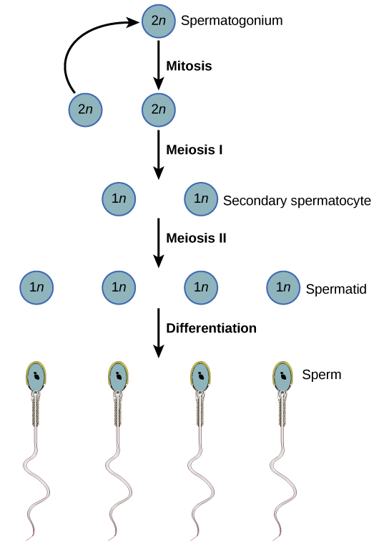Figure 43.3C.143.3�.1: Spermatogenesis: During spermatogenesis, four sperm result from each primary spermatocyte, which divides into two haploid secondary spermatocytes; these cells will go through a second meiotic division to produce four spermatids.

Meiosis begins with a cell called a primary spermatocyte. At the end of the first meiotic division, a haploid cell is produced called a secondary spermatocyte. This haploid cell must go through another meiotic cell division. The cell produced at the end of meiosis is called a spermatid. When it reaches the lumen of the tubule and grows a flagellum (or “tail”), it is called a sperm cell. Four sperm result from each primary spermatocyte that goes through meiosis.

Stem cells are deposited during gestation and are present at birth through the beginning of adolescence, but in an inactive state. During adolescence, gonadotropic hormones from the anterior pituitary cause the activation of these cells and the production of viable sperm. This continues into old age.

**he Ovarian Cycle and the Menstrual Cycle**

The **ovarian cycle** governs the preparation of endocrine tissues and release of eggs, while the **menstrual cycle** governs the preparation and maintenance of the uterine lining. These cycles occur concurrently and are coordinated over a 22–32 day cycle, with an average length of 28 days.

The first half of the ovarian cycle is the follicular phase shown in Figure 1. Slowly rising levels of FSH and LH cause the growth of follicles on the surface of the ovary. This process prepares the egg for ovulation. As the follicles grow, they begin releasing estrogens and a low level of progesterone. Progesterone maintains the endometrium to help ensure pregnancy. The trip through the fallopian tube takes about seven days. At this stage of development, called the morula, there are 30-60 cells. If pregnancy implantation does not occur, the lining is sloughed off. After about five days, estrogen levels rise and the menstrual cycle enters the proliferative phase. The endometrium begins to regrow, replacing the blood vessels and glands that deteriorated during the end of the last cycle.

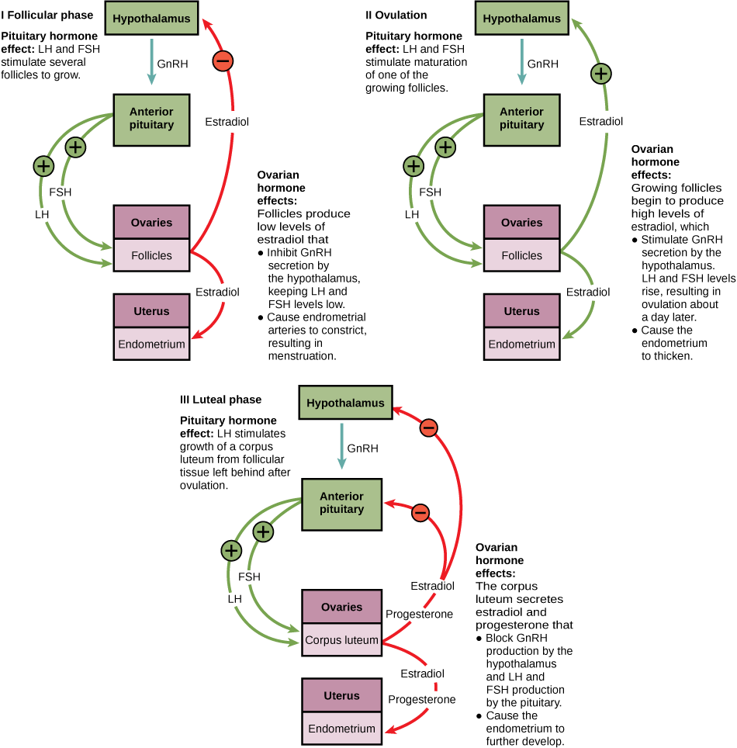

Figure 1. Click for a larger image. The ovarian and menstrual cycles of female reproduction are regulated by hormones produced by the hypothalamus, pituitary, and ovaries.

causes FSH and especially LH to rise rapidly, then fall. The spike in LH causes **ovulation**: the most mature follicle, like that shown in Figure 2, ruptures and releases its egg. The follicles that did not rupture degenerate and their eggs are lost. The level of estrogen decreases when the extra follicles degenerate.

Following ovulation, the ovarian cycle enters its luteal phase, illustrated in Figure 1 and the menstrual cycle enters its secretory phase, both of which run from about day 15 to 28. The luteal and secretory phases refer to changes in the ruptured follicle. The cells in the follicle undergo physical changes and produce a structure called a corpus luteum. The corpus luteum produces estrogen and progesterone. The progesterone facilitates the regrowth of the uterine lining and inhibits the release of further FSH and LH. The uterus is being prepared to accept a fertilized egg, should it occur during this cycle. The inhibition of FSH and LH prevents any further eggs and follicles from developing, while the progesterone is elevated. The level of estrogen produced by the corpus luteum increases to a steady level for the next few days.

If no fertilized egg is implanted into the uterus, the corpus luteum degenerates and the levels of estrogen and progesterone decrease. The endometrium begins to degenerate as the progesterone levels drop, initiating the next menstrual cycle. The decrease in progesterone also allows the hypothalamus to send GnRH to the anterior pituitary, releasing FSH and LH and starting the cycles again. Figure 3 visually compares the ovarian and uterine cycles as well as the commensurate hormone levels.

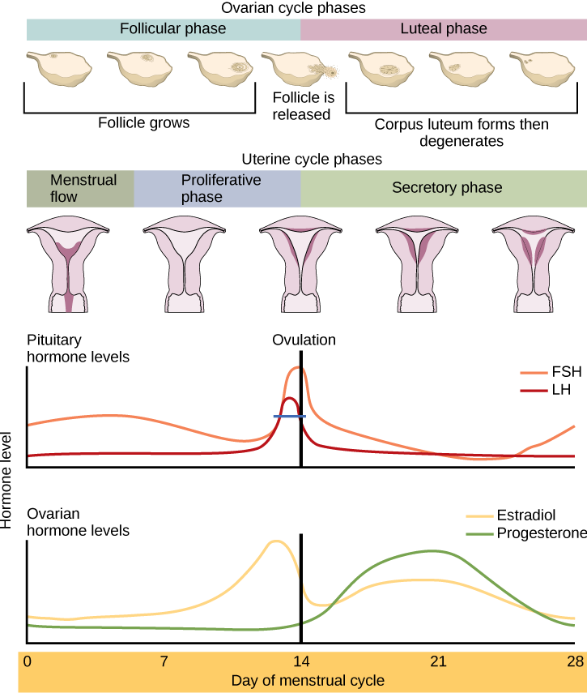

Figure 3. Rising and falling hormone levels result in progression of the ovarian and menstrual cycles. (credit: modification of work by Mikael Häggström)

**Menopause**

As women approach their mid-40s to mid-50s, their ovaries begin to lose their sensitivity to FSH and LH. Menstrual periods become less frequent and finally cease; this is **menopause**. There are still eggs and potential follicles on the ovaries, but without the stimulation of FSH and LH, they will not produce a viable egg to be released. The outcome of this is the inability to have children.

The side effects of menopause include hot flashes, heavy sweating (especially at night), headaches, some hair loss, muscle pain, vaginal dryness, insomnia, depression, weight gain, and mood swings. Estrogen is involved in calcium metabolism and, without it, blood levels of calcium decrease. To replenish the blood, calcium is lost from bone which may decrease the bone density and lead to osteoporosis. Supplementation of estrogen in the form of hormone replacement therapy (HRT) can prevent bone loss, but the therapy can have negative side effects. While HRT is thought to give some protection from colon cancer, osteoporosis, heart disease, macular degeneration, and possibly depression, its negative side effects include increased risk of: stroke or heart attack, blood clots, breast cancer, ovarian cancer, endometrial cancer, gall bladder disease, and possibly dementia.

Female sexual response

The female sexual response is the series of feelings and physical sensations a woman has when she is sexually aroused. Every woman has her own sexual response pattern, which is likely to change over her lifetime.

Emotionally, the healthy sexual response includes feelings of desire, arousal or excitement, and then satisfaction. Many women do not feel desire until they are stimulated enough to become aroused.

Physically, a sexually aroused woman feels:

* Excitement and plateau. The genital area feels "full" as blood fills the blood vessels in the pelvis, vulva, and clitoris. The vagina and vaginal lips (labia) become wet with clear fluid. Muscles begin to tighten up throughout the body, and breathing quickens. This intensifies.
* Climax. Stimulation of the clitoris (and sometimes other sensitive areas) leads to a peak of muscle tension. When this is suddenly released (orgasm), pleasurable muscle contractions in the pelvis follow.
* Resolution. The body relaxes.

For a woman who has suffered abuse, it is common for the sexual response to be mixed with, or blocked by, fear, shame, anxiety, anger, or physical pain.

**Anatomy of a Penis**

The [penis](https://www.webmd.com/men/picture-of-the-penis) is the male sexual organ.

The shaft is the longest part of it. The head or glans is at the end of the shaft. The opening at the tip of the head, where urine and semen come out, is called the meatus.

Inside, two cylinder-shaped chambers called the corpora cavernosa run the length of the [penis](https://www.webmd.com/men/rm-quiz-is-my-penis-normal). They have a maze of [blood](https://www.webmd.com/heart/anatomy-picture-of-blood) vessels, tissue, and open pockets.

The urethra, the tube that urine and semen flow through, runs along the underside of them, in the spongy tissue of the corpus spongiosum.

Two main [arteries](https://www.webmd.com/heart/picture-of-the-arteries) (one in each of the corpora cavernosa) and several veins move [blood](https://www.webmd.com/a-to-z-guides/rm-quiz-blood-basics) in and out. Nerves relay messages to and from other parts of your body.

**What Is an Erection?**

An erection starts in your [brain](https://www.webmd.com/brain/picture-of-the-brain-vue3). Something you saw, felt, smelled, heard, or thought makes your nerves send chemical messages to the blood vessels in your penis. The arteries relax and open up to let more blood flow in; at the same time, the veins close up. Once blood is in the penis, pressure traps it within the corpora cavernosa. Your penis expands and holds the erection.

When the inflow of blood stops and the veins open, your penis becomes soft.

**What Is Ejaculation?**

When you're aroused, tubes called the vas deferens squeeze [sperm](https://www.webmd.com/infertility-and-reproduction/guide/sperm-and-semen-faq) from the testes toward the back of the urethra. The seminal vesicles also release fluid there.

The urethra senses the sperm and fluid mixture. Then, at the height of sexual excitement, it sends signals to your spinal cord, which in turn sends signals to the muscles at the base of your penis. These contract powerfully and quickly, every 0.8 seconds. This forces the semen out of the penis as you climax.

**Effects of testosterone hormones**

Some women with high testosterone levels develop frontal balding. Other possible effects include acne, an enlarged clitoris, increased muscle mass, and deepening of voice. High levels of testosterone can also lead to infertility and are commonly seen in polycystic ovarian syndrome

**Common Reproductive Health Concerns for Women**

endometriosis

Endometriosis is a problem affecting a woman’s uterus—the place where a baby grows when a woman is pregnant. Endometriosis is when the kind of tissue that normally lines the uterus grows somewhere else. It can grow on the ovaries, behind the uterus, on the bowels, or on the bladder. Rarely, it grows in other parts of the body.

This “misplaced” tissue can cause pain, infertility, and very heavy periods. The pain is usually in the abdomen, lower back, or pelvic areas. Some women have no symptoms at all, and having trouble getting pregnant may be the first sign they have endometriosis.

Uterine fibroids

Uterine fibroids are the most common noncancerous tumors in women of childbearing age. Fibroids are made of muscle cells and other tissues that grow in and around the wall of the uterus, or womb. The cause of fibroids is unknown. Risk factors include being African-American or being overweight. The symptoms of fibroids include

* Heavy or painful periods or bleeding between periods.
* Feeling “full” in the lower abdomen.
* Urinating often.
* Pain during sex.
* Lower back pain.
* Reproductive problems, such as infertility, multiple miscarriages, or early labor.

But some women will have no symptoms. That is why it is important to see your health care provider for routine exams.

[Gynecologic Cancer](https://www.cdc.gov/cancer/gynecologic/)

CDC provides information and educational materials for women and health care providers to raise awareness about the five main gynecologic cancers. Gynecologic cancer is any cancer that starts in a woman’s reproductive organs. Gynecologic cancers begin in different places within a woman’s pelvis, which is the area below the stomach and in between the hip bones.

* [Cervical cancer](https://www.cdc.gov/cancer/cervical/index.htm) begins in the cervix, which is the lower, narrow end of the uterus.
* [Ovarian cancer](https://www.cdc.gov/cancer/ovarian/index.htm) begins in the ovaries, which are located on each side of the uterus.
* [Uterine cancer](https://www.cdc.gov/cancer/uterine/index.htm) begins in the uterus, the pear-shaped organ in a woman’s pelvis where the baby grows when a woman is pregnant.
* [Vaginal cancer](https://www.cdc.gov/cancer/vagvulv/index.htm) begins in the vagina, which is the hollow, tube-like channel between the bottom of the uterus and the outside of the body.
* [Vulvar cancer](https://www.cdc.gov/cancer/vagvulv/index.htm) begins in the vulva, the outer part of the female genital organs.

[HIV/AIDS](https://www.cdc.gov/hiv/)

HIV and Breastfeeding

HIV can be spread through breast milk, so mothers in the US who have HIV should not breast-feed their babies.

HIV is the human immunodeficiency virus. HIV affects specific cells of the immune system (called CD4 cells). Over time, HIV can destroy so many of these cells that the body can’t fight off infection anymore. The human body cannot get rid of HIV—that means once a person has HIV, he or she has it for life. There is no cure at this time, but with proper medical care, the virus can be controlled. HIV is the virus that can lead to acquired immune deficiency syndrome, or AIDS. AIDS is the late stage of HIV infection, when a person’s immune system is severely damaged.

**HIV in Women**  
Women who are infected with HIV typically get it by having sex with a man who is infected or by sharing needles with an infected person. Women of minority races/ethnicities are especially affected, and black or African American women are the most affected group.

**Pregnant Women**  
All pregnant women should know their HIV status. Pregnant women who are HIV-positive can work with their health care providers to ensure their babies do not contract HIV during pregnancy, delivery, or after delivery (through breast milk). It is possible for a mother to have HIV and not spread it to her baby, especially if she knows about her HIV status early and works with her health care provider to reduce the risk.  
Learn more from [CDC’s Act Against AIDS](https://www.cdc.gov/actagainstaids/campaigns.html) campaign including [how HIV is spread](https://www.cdc.gov/actagainstaids/basics/transmission.html#ref1), and [how to prevent HIV.](https://www.cdc.gov/actagainstaids/basics/prevention.html#ref1)

[Interstitial Cystitis](https://www.cdc.gov/ic/index.html)

Interstitial cystitis (IC) is a chronic bladder condition resulting in recurring discomfort or pain in the bladder or surrounding pelvic region. People with IC usually have inflamed or irritated bladder walls that can cause scarring and stiffening of the bladder. IC can affect anyone; however, it is more common in women than men. Some people have some or none of the following symptoms:

* Abdominal or pelvic mild discomfort.
* Frequent urination.
* A feeling of urgency to urinate.
* Feeling of abdominal or pelvic pressure.
* Tenderness.
* Intense pain in the bladder or pelvic region.
* Severe lower abdominal pain that intensifies as the urinary bladder fills or empties.

[Polycystic Ovary Syndrome (PCOS)External](http://www.nlm.nih.gov/medlineplus/polycysticovarysyndrome.html)

Polycystic ovary syndrome happens when a woman’s ovaries or adrenal glands produce more male hormones than normal. One result is that cysts (fluid-filled sacs) develop on the ovaries. Women who are obese are more likely to have PCOS. Women with PCOS are at increased risk of developing diabetes and heart disease. Symptoms may include

* [Infertility.](https://www.cdc.gov/reproductivehealth/infertility/index.htm)
* Pelvic pain.
* Excess hair growth on the face, chest, stomach, thumbs, or toes.
* Baldness or thinning hair.
* Acne, oily skin, or dandruff.
* Patches of thickened dark brown or black skin.

Sexually Transmitted Diseases (STDs)

STDs are infections that you can get from having sex with someone who has the infection. The causes of STDs are bacteria, parasites, and viruses. There are more than 20 types of STDs. [Read more about specific STDs from these CDC fact sheets](https://www.cdc.gov/std/healthcomm/fact_sheets.htm).  
Most STDs affect both men and women, but in many cases the health problems they cause can be more severe for women. If a pregnant woman has an STD, it can cause serious health problems for the baby.

If you have an STD caused by bacteria or parasites, your health care provider can treat it with antibiotics or other medicines. If you have an STD caused by a virus, there is no cure, but antiviral medication can help control symptoms. Sometimes medicines can keep the disease under control. Correct usage of latex condoms greatly reduces, but does not completely eliminate, the risk of catching or spreading STDs.

**Male reproductive organs conditions**

Top of Form

Bottom of Form

[**Testicular Cancer**](https://www.theurologyfoundation.org/urologyhealth/male-reproductive-organs/testicular-cancer)

Testicular cancer is one of the most beatable cancers when detected early. Nearly all men are cured.

[**Cancer of the Penis (Penile Cancer)**](https://www.theurologyfoundation.org/urologyhealth/male-reproductive-organs/cancer-of-the-penis-penile-cancer)

Cancer of the penis, or penile cancer, rarely affects men under 40, and only 1 in 100,000 men overall. It is a potentially fatal condition. With penile cancer, tumours usually appear on the end of the penis or on the foreskin.

[**Phimosis (Foreskin Problems)**](https://www.theurologyfoundation.org/urologyhealth/male-reproductive-organs/phimosis-foreskin-problems)

When boys are first born, their foreskin is tight. Over time it gradually loosens until it can be easily pulled back over the penis head (glans). Phimosis occurs when the foreskin remains unusually tight and cannot be drawn back.

[**Testicular Torsion**](https://www.theurologyfoundation.org/urologyhealth/male-reproductive-organs/470-testicular-torsion)

Testicular torsion occurs occurs due to the rotation and twisting of the testicle. This causes swelling and evetually cuts off the blood supply to the testicle.

[**Male Infertility**](https://www.theurologyfoundation.org/urologyhealth/male-reproductive-organs/male-infertility)

Infertility is the inability to produce children after at least one year of unprotected intercourse. About one in six couples have difficulty getting pregnant, and male infertility is the cause in a quarter of cases.

[**Vasectomy**](https://www.theurologyfoundation.org/urologyhealth/male-reproductive-organs/vasectomy)

A vasectomy is a surgical form of contraception. The operation involves cutting and tying the tubes (called vas deferens) that deliver sperm from the testes to the prostate to make semen.

[**Erectile Dysfunction**](https://www.theurologyfoundation.org/urologyhealth/male-reproductive-organs/erectile-dysfunction)

Erectile dysfunction (ED) is the persistent or recurrent inability to achieve or maintain an erection sufficient for sexual activity. It is sometimes known as 'impotence'. It's a very common problem, particularly affecting men past the age of 40, and around 1 in 10 men overall.

[**Priapism**](https://www.theurologyfoundation.org/urologyhealth/male-reproductive-organs/priapism)

Priapism is the medical term for a persistent erection that lasts at least 4 hours. It is usually painful, and may not be related to sexual stimulation or activity. Left untreated, it can cause lasting damage to the penis.

[**Peyronie's Disease**](https://www.theurologyfoundation.org/urologyhealth/male-reproductive-organs/peyronie-s-disease)

Peyronie's disease causes scar tissue, or a hard lump, to form inside the penis. The cause is not really known, though trauma (such as hitting or bending) of the penis may be involved.

[**Varicoceles**](https://www.theurologyfoundation.org/urologyhealth/male-reproductive-organs/varicoceles)

A varicocele is a varicose vein above the testicles. All veins have valves inside them that keep the blood moving in one direction. With varicose veins, these valves have failed and blood can pool, eventually making the veins bulge.

[**Blood in Semen**](https://www.theurologyfoundation.org/urologyhealth/male-reproductive-organs/576-blood-in-semen)

Haematospermia is a condition that refers to the presence of visible blood in ejaculate (semen)

[**Hydrocele**](https://www.theurologyfoundation.org/urologyhealth/male-reproductive-organs/483-hydrocele)

A hydrocele is a collection of fluid around the testicle beneath its outer covering. If the hydrocele is small and doesn’t cause any troubling symptoms, it may not require any treatment

**11.0. THE SKIN**

**11.1. Picture of the Skin**

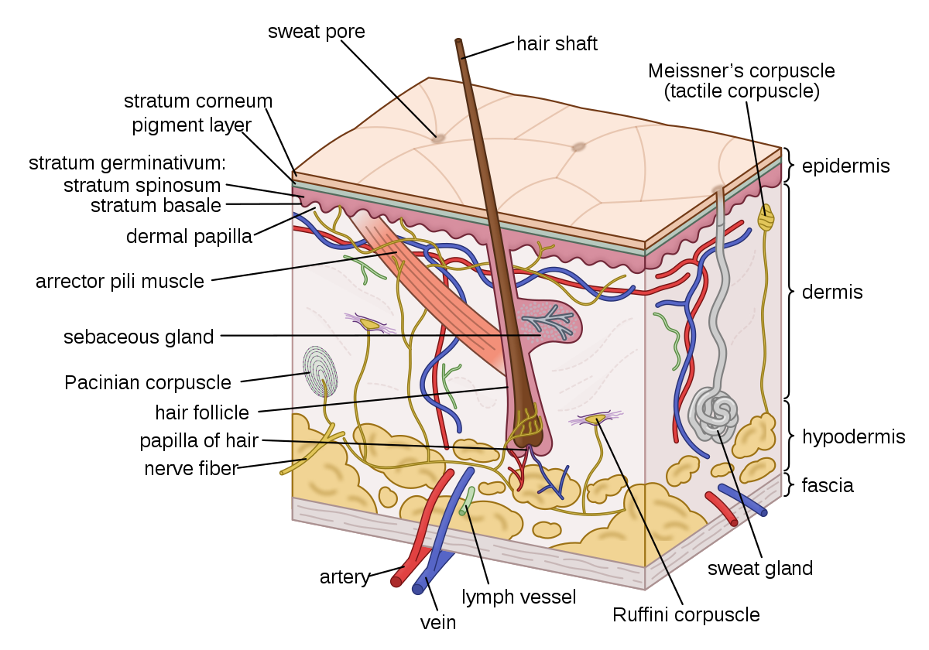

The skin is the largest organ of the body, with a total area of about 20 square feet. The skin protects us from microbes and the elements, helps regulate body temperature, and permits the sensations of touch, heat, and cold.

Skin has three layers:

* The epidermis, the outermost layer of skin, provides a waterproof barrier and creates our skin tone.
* The dermis, beneath the epidermis, contains tough connective tissue, hair follicles, and sweat glands.
* The deeper subcutaneous tissue (hypodermis) is made of fat and connective tissue.

The skin’s color is created by special cells called melanocytes, which produce the pigment melanin. Melanocytes are located in the epidermis.

**11.2. Skin Conditions**

* [Rash](https://www.webmd.com/skin-problems-and-treatments/guide/common-rashes): Nearly any change in the skin’s appearance can be called a [rash](https://www.webmd.com/skin-problems-and-treatments/guide/common-rashes). Most rashes are from simple skin irritation; others result from medical conditions.
* [Dermatitis](https://www.webmd.com/skin-problems-and-treatments/understanding-dermatitis-basics): A general term for inflammation of the skin. Atopic dermatitis (a type of eczema) is the most common form.
* [Eczema](https://www.webmd.com/skin-problems-and-treatments/eczema/understanding-eczema-basics): Skin inflammation ([dermatitis](https://www.webmd.com/skin-problems-and-treatments/contact-dermatitis)) causing an itchy rash. Most often, it’s due to an overactive immune system.
* [Psoriasis](https://www.webmd.com/skin-problems-and-treatments/psoriasis/psoriasis-topic-overview): An autoimmune condition that can cause a variety of skin rashes. Silver, scaly plaques on the skin are the most common form.
* [Dandruff](https://www.webmd.com/skin-problems-and-treatments/understanding-dandruff-basics): A scaly condition of the scalp may be caused by seborrheic dermatitis, psoriasis, or eczema.
* [Acne](https://www.webmd.com/skin-problems-and-treatments/acne/acne-vulgaris-topic-overview): The most common skin condition, acne affects over 85% of people at some time in life.
* [Cellulitis](https://www.webmd.com/skin-problems-and-treatments/guide/cellulitis): Inflammation of the dermis and subcutaneous tissues, usually due to an infection. A red, warm, often painful skin rash generally results.
* [Skin abscess](https://www.webmd.com/a-to-z-guides/abcess) (boil or furuncle): A localized skin infection creates a collection of pus under the skin. Some abscesses must be opened and drained by a doctor in order to be cured.
* [Rosacea](https://www.webmd.com/skin-problems-and-treatments/understanding-rosacea-basics): A chronic skin condition causing a red rash on the face. Rosacea may look like acne, and is poorly understood.
* [Warts](https://www.webmd.com/skin-problems-and-treatments/understanding-common-warts-basics): A virus infects the skin and causes the skin to grow excessively, creating a wart. Warts may be treated at home with chemicals, duct tape, or freezing, or removed by a physician.
* [Melanoma](https://www.webmd.com/melanoma-skin-cancer/melanoma-guide/melanoma-skin-cancer-overview-facts): The most dangerous type of skin cancer, melanoma results from sun damage and other causes. A skin biopsy can identify melanoma.
* [Basal cell carcinoma](https://www.webmd.com/melanoma-skin-cancer/basal-cell-carcinoma): The most common type of skin cancer. Basal cell carcinoma is less dangerous than melanoma because it grows and spreads more slowly.
* [Seborrheic keratosis](https://www.webmd.com/skin-problems-and-treatments/tc/seborrheic-keratosis-topic-overview): A benign, often itchy growth that appears like a “stuck-on” wart. Seborrheic keratoses may be removed by a physician, if bothersome.
* [Actinic keratosis](https://www.webmd.com/melanoma-skin-cancer/understanding-actinic-keratosis-basics): A crusty or scaly bump that forms on sun-exposed skin. [Actinic keratoses](https://www.webmd.com/skin-problems-and-treatments/understanding-actinic-keratosis-basics) can sometimes progress to cancer.
* [Squamous cell carcinoma](https://www.webmd.com/cancer/carcinoma-squamous-cell): A common form of skin cancer, squamous cell carcinoma may begin as an ulcer that won’t heal, or an abnormal growth. It usually develops in sun-exposed areas.
* [Herpes](https://www.webmd.com/genital-herpes/pain-management-herpes): The herpes viruses HSV-1 and HSV-2 can cause periodic blisters or skin irritation around the lips or the genitals.
* [Hives](https://www.webmd.com/skin-problems-and-treatments/guide/hives-urticaria-angioedema): Raised, red, itchy patches on the skin that arise suddenly. Hives usually result from an allergic reaction.
* [Tinea versicolor](https://www.webmd.com/skin-problems-and-treatments/tc/tinea-versicolor-topic-overview): A benign fungal skin infection creates pale areas of low pigmentation on the skin.
* [Viral exantham](https://firstaid.webmd.com/skin-rashes-in-children-treatment): Many viral infections can cause a red rash affecting large areas of the skin. This is especially common in children.
* [Shingles](https://www.webmd.com/skin-problems-and-treatments/shingles/shingles-topic-overview) (herpes zoster): Caused by the chickenpox virus, shingles is a painful rash on one side of the body. A new adult vaccine can prevent shingles in most people.
* [Scabies](https://www.webmd.com/skin-problems-and-treatments/understanding-lice-scabies-basics): Tiny mites that burrow into the skin cause scabies. An intensely itchy rash in the webs of fingers, wrists, elbows, and buttocks is typical of scabies.
* [Ringworm](https://www.webmd.com/skin-problems-and-treatments/understanding-ringworm-basics): A fungal skin infection (also called tinea). The characteristic rings it creates are not due to worms.

**12.0 Sensory organs**

**12.1. Basic features of sensory structures**

(1) All sense organs contain [receptor](https://www.britannica.com/science/receptor-nerve-ending) cells that are specifically sensitive to one class of stimulus energies, usually within a restricted range of intensity. Such selectivity means that each receptor has its own “adequate” or proper or normal stimulus, as, for example, light is the adequate stimulus for [vision](https://www.britannica.com/science/vision-physiology). However, other energies (“inadequate” stimuli) can also activate the receptor if they are sufficiently intense. Thus, one may “see” pressure when, for example, the thumb is placed on a closed eye and one sees a bright spot ([phosphene](https://www.britannica.com/topic/phosphene)) in the visual field at a position opposite the touched place

(2) The sensitive mechanism for each [modality](https://www.merriam-webster.com/dictionary/modality) is often localized in the body at a receiving membrane or surface (such as the [retina](https://www.britannica.com/science/retina) of the [eye](https://www.britannica.com/science/human-eye)) where transducer neurons (sensory cells) are located. Often the sensory organ incorporates accessory structures to guide the stimulating energy to the receptor cells; thus, the normally transparent [cornea](https://www.britannica.com/science/cornea) and [lens](https://www.britannica.com/science/lens-eye-structure) within the eye focus light on the retinal sensory neurons

(3) The primary transducers or sensory cells in any receptor structure normally connect ([synapse](https://www.britannica.com/science/synapse)) with secondary, ingoing ([afferent](https://www.britannica.com/science/afferent-nerve)) nerve cells that carry the nerve impulse. In some receptors, such as the [skin](https://www.britannica.com/science/human-skin), the individual primary cells possess threadlike structures ([axons](https://www.britannica.com/science/axon)) that may be yards long, winding from just beneath the skin surface through subcutaneous tissues until they reach the [spinal cord](https://www.britannica.com/science/spinal-cord).

**a. Eye**

To understand the diseases and conditions that can affect the eye, it helps to understand basic eye anatomy. Here is a tour of the eye starting from the outside, going in through the front and working to the back.

**Eye Anatomy: Parts of the Eye Outside the Eyeball**

The eye sits in a protective bony socket called the orbit. Six [extraocular muscles](https://www.aao.org/eye-health/anatomy/eye-muscles) in the orbit are attached to the eye. These muscles move the eye up and down, side to side, and rotate the eye.

The extraocular muscles are attached to the white part of the eye called the [sclera](https://www.aao.org/eye-health/anatomy/sclera). This is a strong layer of tissue that covers nearly the entire surface of the eyeball.

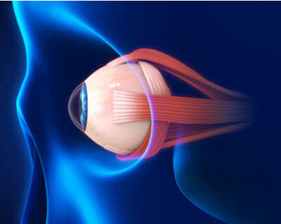

*This illustration shows eye muscles, which control eye movement.*

The Surface of the Eye

The surface of the eye and the inner surface of the [eyelids](https://www.aao.org/eye-health/anatomy/eyelid-4) are covered with a clear membrane called the [conjunctiva](https://www.aao.org/eye-health/anatomy/conjunctiva-3).

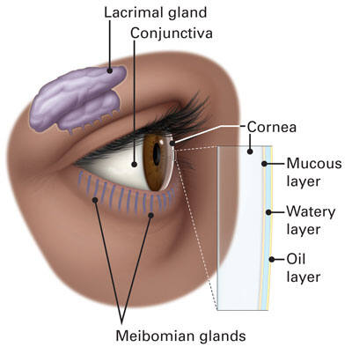

*The layers of the tear film keep the front of the eye lubricated.*

[Tears lubricate the eye](https://www.aao.org/eye-health/tips-prevention/facts-about-tears) and are made up of three layers. These three layers together are called the [tear film](https://www.aao.org/eye-health/anatomy/tear-film-3). The mucous layer is made by the conjunctiva. The watery part of the tears is made by the [lacrimal gland](https://www.aao.org/eye-health/anatomy/lacrimal-gland). The eye’s lacrimal gland sits under the outside edge of the eyebrow (away from the nose) in the orbit. The [meibomian gland](https://www.aao.org/eye-health/anatomy/meibomian-glands) makes the oil that becomes another part of the tear film. Tears drain from the eye through the [tear duct](https://www.aao.org/eye-health/anatomy/tear-duct).

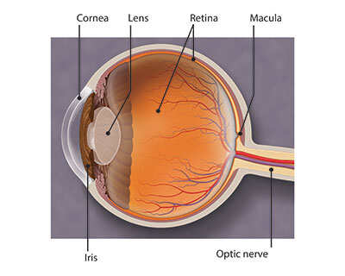

The Front of the Eye

Light is focused into the eye through the clear, dome-shaped front portion of the eye called the [cornea](https://www.aao.org/eye-health/anatomy/cornea-103).

Behind the cornea is a fluid-filled space called the anterior chamber. The fluid is called [aqueous humor](https://www.aao.org/eye-health/anatomy/aqueous-humor). The eye is always producing aqueous humor. To maintain a constant [eye pressure](https://www.aao.org/eye-health/anatomy/eye-pressure), aqueous humor also drains from the eye in an area called the [drainage angle](https://www.aao.org/eye-health/anatomy/drainage-angle).

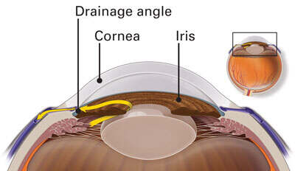

Behind the anterior chamber is the eye’s [iris](https://www.aao.org/eye-health/anatomy/iris-2) (the colored part of the eye) and the dark hole in the middle called the [pupil](https://www.aao.org/eye-health/anatomy/pupil). Muscles in the iris dilate (widen) or constrict (narrow) the pupil to control the amount of light reaching the back of the eye.

Directly behind the pupil sits the [lens](https://www.aao.org/eye-health/anatomy/lens-9). The lens focuses light toward the back of the eye. The lens changes shape to help the eye focus on objects up close. Small fibers called zonules are attached to the capsule holding the lens, suspending it from the eye wall. The lens is surrounded by the [lens capsule](https://www.aao.org/eye-health/anatomy/lens-capsule-definition), which is left in place when the lens is removed during [cataract surgery](https://www.aao.org/eye-health/diseases/what-is-cataract-surgery). Some types of replacement intraocular lenses go inside the capsule, where the natural lens was.

By helping to focus light as it enters the eye, the cornea and the lens both play important roles in giving us clear vision. In fact, 70% of the eye's focusing power comes from the cornea and 30% from the lens.

The Back of the Eye

The vitreous cavity lies between the lens and the back of the eye. A jellylike substance called [vitreous humor](https://www.aao.org/eye-health/anatomy/vitreous) fills the cavity.

Light that is focused into the eye by the cornea and lens passes through the vitreous onto the [retina](https://www.aao.org/eye-health/anatomy/retina-103) — the light-sensitive tissue lining the back of the eye.

A tiny but very specialized area of the retina called the [macula](https://www.aao.org/eye-health/anatomy/macula-6) is responsible for giving us our detailed, central vision. The other part of the retina, the [peripheral retina](https://www.aao.org/eye-health/anatomy/peripheral-retina), provides us with our peripheral (side) vision.

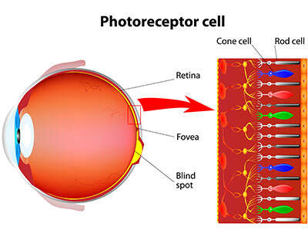

The retina has special cells called [photoreceptors](https://www.aao.org/eye-health/anatomy/photoreceptors). These cells change light into energy that is transmitted to the brain. There are two types of photoreceptors: [rods](https://www.aao.org/eye-health/anatomy/rods) and [cones](https://www.aao.org/eye-health/anatomy/cones). Rods perceive black and white, and enable [night vision](https://www.aao.org/eye-health/anatomy/night-vision). Cones [perceive color](https://www.aao.org/eye-health/tips-prevention/how-humans-see-in-color), and provide central (detail) vision.

The retina sends light as electrical impulses through the [optic nerve](https://www.aao.org/eye-health/anatomy/optic-nerve-3) to the brain. The optic nerve is made up of millions of nerve fibers that transmit these impulses to the visual cortex — the part of the brain responsible for ou

* 1. **Ear**

[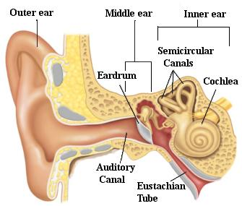](https://scioly.org/wiki/index.php/File:Ear.jpg)

Diagram of the ear

Ear- the organ of hearing. The outer ear protrudes away from the head and is shaped like a cup to direct sounds toward the tympanic membrane, which transmits vibrations to the inner ear through a series of small bones in the middle ear called the malleus, incus and stapes. The inner ear, or cochlea, is a spiral-shaped chamber covered internally by nerve fibers that react to the vibrations and transmit impulses to the brain via the auditory nerve. The brain combines the input of our two ears to determine the direction and distance of sounds. The inner ear has a vestibular system formed by three semicircular canals that are approximately at right angles to each other and which are responsible for the sense of balance and spatial orientation. The inner ear has chambers filled with a viscous fluid and small particles (otoliths) containing calcium carbonate. The movement of these particles over small hair cells in the inner ear sends signals to the brain that are interpreted as motion and acceleration. The human ear can perceive frequencies from 16 cycles per second, which is a very deep bass, to 28,000 cycles per second, which is a very high pitch. The human ear can detect pitch changes as small as 3 hundredths of one percent of the original frequency in some frequency ranges. Some people have "perfect pitch", which is the ability to map a tone precisely on the musical scale without reference to an external standard.

* 1. **Nose**

[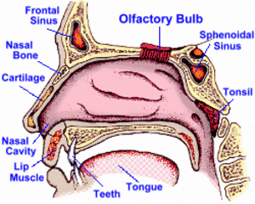](https://scioly.org/wiki/index.php/File:Nose.png)

Diagram of the nose

Nose- the organ of smell. The nose is the organ responsible for the sense of smell. The cavity of the nose is lined with mucous membranes that have smell receptors connected to the olfactory nerve. The smells themselves consist of vapors of various substances. The smell receptors interact with the molecules of these vapors and transmit the sensations to the brain. The nose also has a structure called the vomeronasal organ whose function has not been determined, but which is suspected of being sensitive to pheromones that influence the reproductive cycle. The smell receptors are sensitive to seven types of sensations that can be characterized as camphor, musk, flower, mint, ether, acrid, or putrid. The sense of smell is sometimes temporarily lost when a person has a cold.

[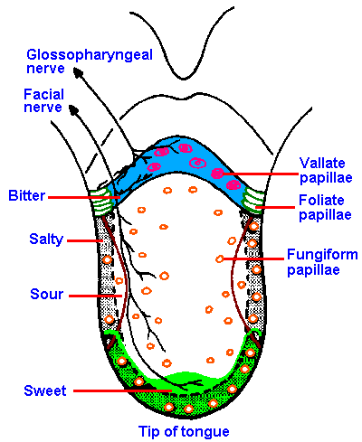](https://scioly.org/wiki/index.php/File:Tongue.jpg)

* 1. **The tongue**

Tongue- the organ of taste. The receptors for taste, called taste buds, are situated chiefly in the tongue, but they are also located in the roof of the mouth and near the pharynx. They are able to detect four basic tastes: salty, sweet, bitter, and sour. The tongue also can detect a sensation called "umami" from taste receptors sensitive to amino acids. Generally, the taste buds close to the tip of the tongue are sensitive to sweet tastes, whereas those in the back of the tongue are sensitive to bitter tastes. The taste buds on top and on the side of the tongue are sensitive to salty and sour tastes. At the base of each taste bud there is a nerve that sends the sensations to the brain. The sense of taste functions in coordination with the sense of smell. The number of taste buds varies substantially from individual to individual, but greater numbers increase sensitivity. The gouge is covered with papillae which makes the tongue have a rough texture.